LARGE FARM TOY AUCTION
SAT. SEPT. 19 10:00 A.M.!
(Preview: Fri. Sept. 18, 10-Noon)
JANE ADDAMS COMMUNITY CENTER
430 W. WASHINGTON ST., CEDARVILLE, IL 61013
FARM TOYS: JD 8760 Tractor 4x4; JD PRECISION: 720 w/ blade, 3010 nf, T145 Plow,
B styled, A unstyled, A w/ 2 R. Cultivator, 4020 w/ Picker; 4020 nf, 4000; IHC Precision Regular; IHC Precision F-20; Ford Precision 8N; 1996 WI Farm Progress IHC S-M & Wagon; 100+ 1/64th Tractors & Implements. SPECIAL (ALL 4X4 NIB 1/32ND): Steiger Cougar II;
AC 4W/305; Steiger Wildcat Super I; Steiger Wildcat I; Steiger Wildcat II; MM A4T-1600; Titan STR 360; Case 4890; AC 440; Steiger Bearcat II (COOP); IHC 7788; Versatile 935, 950; MF 1500; MF 4840; Case 2470; White 4-210; IHC 3788 2+2; JD 7020; IHC 4786, 4365; Steiger Panther 325; Steiger Tiger KP 525. DEVRIES COLLECTION, FORRESTON, IL: Oliver 7- steel; Oliver 70 Diesel; Gleaner Combine w/ header; Oliver 440; White American Series; Spirit Oliver; Nylint Hook & Ladder Fire Truck; NI Uni 800 Ear Corn Picker; NI Uni 800C w/ 6 row head;
NI Uni 800 Grey; NI 800 Orange (20 Anniv); Gehl Ash Tray; NI Plastic Spreader; MF 98 Forreston Show.
BOB WESTGARD, JUDA, WI FARM TOYS: IHC 1256 nf; Case 730 w/ Wagon; Ideal Industrial 1/16th Semi Truck; JD 4020 Restoration; 1170 Case T.F.; IHC 706; CIH Axial Flow 9230 Prestige Combine; 2 Red Power IHC 460 w/ Loader; IHC 806 Fox Fire; IHC Precision 460; JD FFA A; 3 1/64th IHC Semi Trucks. OTHER TOYS & LITERATURE: RARE Scale Model Oliver 2455 Collectors Structo Fire Truck; Structo Wrecker; Tin Marx Gas Station; 2 Weeden Steam Engines; Mint Freeport/Florence Greyhound Bus; 50+ Felt Pennant: Sports, College, Freeport Pretzels 1951; Flats of Tractor Manuals; Flats of Tractor Literature; Flats of Car Literature; JD 9 RX540 Prestige; Oliver S-77; IHC 1206 Wheatland; MM G-1000 w/ cab; Pocket Ledgers 1940-50’s; 20+ American Muscle Cars; Barbie Dolls in orig. boxes; Boxes paper Dolls; Barbie Doll Case; 250+ Beanie Babies; Plus more items!
Terms: Cash or check w/ picture ID. Auction held inside w/ seating, lunch & restrooms available.
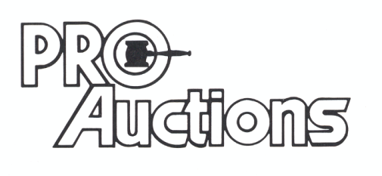 www.Proauctionsllc.com www.auctionzip.com
, LLC
RICK GARNHART, AUCTIONEER 815-238-3044
German Valley, IL 61039
IL Lic. #440000901 WI Lic. #2844-52

