LARGE FARM TOY AUCTION
SAT. OCT. 24 10:00 A.M.!
(OPEN HOUSE: FRIDAY SAT. 23, 10-NOON)
JANE ADDAMS COMMUNITY CENTER
430 W. WASHINGTON ST., CEDARVILLE, IL 61013
500+ FARM TOYS & TRUCKS
CHARLES & GLORIA OPIE ESTATE, GRATIOT, WI: Rare White 2-70 Pedal Tractor w/ FWA autographed by Joe Erytl 2001; Farm Tech Skid loader, Grant Co, WI; OLIVER: 1955, 88, 1850 FWA, 440, 550, 60, OC3, Pink 1950, 1900 checkerboard; JD: 4620 Cheese Days, 5020, 8300, 9500, 630 Prestige, 7610, 9300T; Case 970; AC: D-21, D-17, 200, 6010, 8630 FWA; Hubley Tractors; IHC: 3-1586, M, 660IND, White C, F-20; Rare IHC Mix Mill; Nylint Trucks; 1/16 Semi Trucks; Coca Cola Truck; Seed Corn Collectibles; Lg. Archer Oil Dealer Collection incl. Adv, Oil Samples, Cans, etc; Assort. Misc. Farm Implements, Assort. Misc. Trucks.

SMALL ESTATE WI-70+ TRACTORS, NIB: CIH 340; Claas 5000 Prestige; MM: 44 w/ loader, G-1000 Vista Duals, U w/ 2 row Planter, 445 LP, U-Narrow front, 400 Corn Planter;
JD: 720 Precision, 70 Precision, A Precision, 4020 Precision, A w/ Cultivator Precision; CASE: DC, DC-4; IHC: 340 w/ Planter, F-20, 544 w/ loader, 806, hydro 70; IHC & Kasten Forage Wagons; Cat-Terricin 297D2; Versatile 950 Prestige NFTM; AC: 440, D-21, 7580, D-17 Prestige, D-19; 2 Ford 8N Restoration; OLIVER: 1650 FWA, 1750 WF, 1855 Firestone; Small Collection Structo Trucks incl: Car Hauler w/ ramp, Van, Army Truck, Dump Truck, 3 Cadillac’s, Hook & Ladder Fire Truck.
Assorted 1/32nd Tractors and Assorted 1/32nd 4x4. Numerous Toys not listed.

Terms: Cash or check w/ picture ID. Auction held inside w/ seating, lunch stand and restrooms available.
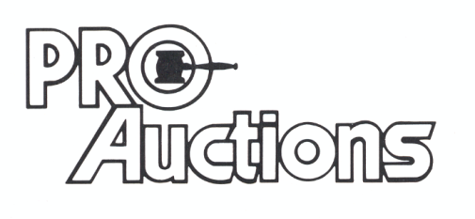 www.Proauctionsllc.com www.auctionzip.com
, LLC
RICK GARNHART, AUCTIONEER 815-238-3044
German Valley, IL 61039
IL Lic. #440000901 WI Lic. #2844-52

