LARGE FARM TOY & PEDAL TRACTOR AUCTION
SAT. JUNE 20 10:00 A.M.!
(Preview: Fri. June 19, 10-Noon)
JANE ADDAMS COMMUNITY CENTER
430 W. WASHINGTON ST., CEDARVILLE, IL 61013
15 PEDAL TRACTORS & WAGONS: Rare Oliver Closed side 88 Diesel, restored; Rare IHC Eska 450 , restored; JD 7020 4x4, JD 4020 wf; JD 40 Series NF; IHC 806; IHC- M; IHC 5,000,000 Edition; 2-JD 520; AC 7080 w/ trailer; IHC SM w/ trailer; JD 20 w/ metal trailer; AC 45 w/ trailer; IHC SH “Max Armstrong”; IHC 404 (1066); 1980 JD Coaster Wagon; 1920 Wooden Consumer Store Coaster Wagon. FARM TOYS: 2 Rare Grand Touring Ski-Doo Sno Mobiles; Rare Brady Mix Mill; JD: 8760 4x4, 4860 fwa, 4850, 630 LP, 2550, A steel & rubber; 860 4x4, 8640 4x4, 6000-7000 kit Tractor; 7600 fwa, 8560 4x4, 8630 4x4, 8630, 4955, 2- H.C. 720, 6 B. Plow, Waterloo Boy, BR, D, G, A, 70, Orchard 60, 2 Cylinder Expo Tractor, Dubuque M, 9760 4WD, 9600 Combine, 5010, 3010, 70 w/ NI Loader custom; PRECISION JD: 4020, A w/ Cultivator, H.C. 720, B Tractor, 4020; Ford 8000 w/ wagon; Gleaner w/ 6 R. Head & Grain;
3 Ertyl Farm Sets, NIB; 1/64th Semi Trucks; 10+ Coca Cola Trucks; Radio Control Peter Bilt Truck; Win-Ross Trucks; IHC Precision F-20; IHC 350 World Pork; IHC 706 Custom; IHC MV; Assort. IHC Implements; Semi Dump Trailer; Flat Bed Trailer; Ertyl Grain & Stock Truck; Dearborn Precision Plow & Blade; White 9700 Combine; MM G-1000 NIB, Plainsman NIB; MM 4 Star; NI Loader; Plus more. MISC. ITEMS: 500+ Hot Wheels Cars; Lots Farm Literature & Magazines; Freeport Items; Florence Station Bus; Metal Service Center; Old Tractor Show Magazines; Breyer Horses; Disney Collectibles. Note: Large sale of high quality Pedals & Farm Toys, some rare. See pictures on websites. Terms: Cash or check w/ picture ID. Auction held inside w/ seating, lunch & restrooms available.
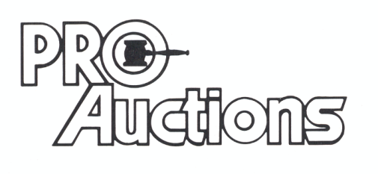 www.Proauctionsllc.com www.auctionzip.com
, LLC
RICK GARNHART, AUCTIONEER 815-238-3044
German Valley, IL 61039
IL Lic. #440000901 WI Lic. #2844-52

