LARGE FARM TOY AUCTION
SAT. APRIL 25 10:00 A.M.
(PREVIEW: FRIDAY, APRIL 24 10 A.M.-NOON)
JANE ADDAMS COMMUNITY CENTER
430 W. WASHINGTON ST., CEDARVILLE, IL 61013
150-200 J.D.TOY TRACTORS & IMPLEMENTS-MOST NIB:
PRECISION JD: 630, 70 Standard, 720 D, 70 D, 730 D, 5010, 4020; PRECISION FARMALL: F-20, M, H; JD Metal Barn Quilt 36” x 36”; Rare F/S 1/16th Semi Truck; Harley Davidson Items; JD: 4955, 4020, 8020, 4010, 730, 4630, 6030, 6030, 7800, 4320, 4020 Prestige, 4230, 3020 /4020 Set; 9320, 8520 w/ triples, 2-55 Combines, 5 B. Plow, 2 Turbo Combines, Custom Puller.
OTHER: AG Chem Floater; Operators Manuals; WI Progress Days Tractor; Fox Fire IHC 1206; Lots Farm Magazines; Auto Literature; Structo Trucks; Freeport, IL Kiwanis Banks; Kelly-Springfield Trucks; 13 Win-Ross Kelly-Springfield Semi’s; 100+ 1/64th & 1/32nd Tractors; 500+ Hot Wheels Cars; Marbles; Florence Station Bus; Plastic Farm Buildings; Metal Gas Station; Felt Pennant Collection; Budweiser Lighted Sign; 100+ Record Albums; Old Calendars; Freeport, IL Engine Club Plates; Die-Cast Cars; 12 Old Kerosene Lamps; 30 Jars full Button Collection.
Note: This is a brief list. So much more. Also be sure to see pictures. Call Auctioneer for more information. Terms: Cash or check w/ picture ID. Auction held inside w/ seating, lunch & restrooms available.
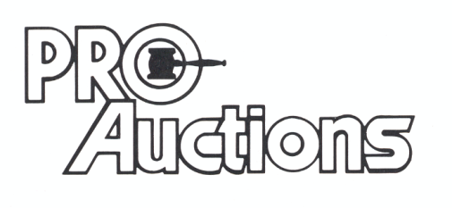 www.Proauctionsllc.com www.auctionzip.com
, LLC
RICK GARNHART, AUCTIONEER 815-238-3044
German Valley, IL 61039
IL Lic. #440000901 WI Lic. #2844-52

