HUGE PEDAL TRACTOR &
FARM TOY AUCTION
SAT. FEB. 7, 2026 10:00 A.M.
(STORM DATE: SUNDAY FEB. 8)
EDWARD MEIER ESTATE, CHADWICK, IL
SALE HELD AT: JANE ADDAMS COMMUNITY CENTER
430 W. WASHINGTON ST., CEDARVILLE, IL 61013
41 RESTORED & ORIG. PEDAL TRACTORS: Rare MM Shuttle Shift Pedal, Case VAC; Oliver 88 Closed Side Diesel; MH 44; IHC ESKA M; JD ESKA A, 3 hole; JD A; CIH 7130 WF; Ford 7740 WF; JD 7600 WF; Fire Chief Pedal Car; IHC ESKA H; IHC ESKA 560; ESKA 400; ESKA 450; IHC 1026; IHC 806; IHC 856; Cub Cadet Pedal; IHC 1066; IHC 86; CIH Magnum; Case 1070; AC D-17; Oliver 1800; Oliver/White 1855; Ford TW20; 2-JD20; JD 130; 2 JD A w/ umbrellas;
JD 6400 w/ loader; JD LGT Pedal; JD 10-4 Hole, side shifter; JD 10-3 Hole, side Shifter;
MF 1100; MH 44 Special; JD Custom 4440; JD Pedal Car; Case Trailer; U-Haul Trailer; 2-IHC Fender Trailers; 2- JD Trailers. FARM TOYS & OTHER: 200+ 1/64th Tractors & Implements;
JD- all 4x4: 9400, 8870, 8760, 8650, 8040; AC: 7060, 190XT, D-17, 4W305; IHC: 1206 Wheatland, 7250, 1206, 706, 806, 560, 1066, 100 Hydro, 1568-V8, 1468 V8; Oliver 1800; Versatile 825; True Scale; Structo Trucks; 1/64th Semi Trucks; 2 Custom JD Wagons w/ Horses; 1/8th Custom Double Box w/ seat; Pens & Pencils; Yardstick Adver; Case Tool Box; 3 Cast Iron Seats; Hubley; Model Fire Truck, Milwaukee; Small Seed Corn Adver. Items; Small Truck Bank Collection; JD Wooden Bench; Plus more Misc. Items. Note: Rare, high quality Pedal Tractors and Farm Toys. Super Collection. Viewing on Friday from 10-Noon.
Terms: Cash or check w/ picture ID. Auction held inside w/ seating, lunch and restrooms available.
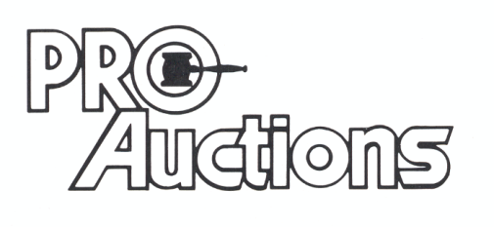 www.Proauctionsllc.com www.auctionzip.com RICK GARNHART, AUCTIONEER
, LLC
German Valley, IL 61039
815-238-3044
IL Lic: 440000901 WI Lic: 2844-52

