STRUCTO TOYS, HUNTING, FISHING ITEMS AUCTION
SAT. APRIL 4 10:00 A.M.!
OPEN HOUSE: FRIDAY APRIL 3: 10-NOON
CHARLES(CHUCK)HAYS ESTATE
JANE ADDAMS COMMUNITY CENTER
430 W. WASHINGTON ST., CEDARVILLE, IL 61013
STRUCTO TOYS: Boats; Boat Motors; Machinery Hauler; Car Hauler; Cadillac; Buick; Pickup Trucks; Semi-Trucks; Stake Truck; Oil Tanker; Hyd. Dump Trucks; Garbage Trucks; Army Supply; Fire Trucks; Highway Trucks; Structo Kitchen Set. OTHERS: Nylint; Wyandotte; Tootsie Toys; Hot Wheels; True Scale; Hubley; Midge Toys; Arcade; Multiple Show Cases & Display Racks. HUNTING ITEMS: 100 Fixed Blade Knives; 100 Pocket Knives; Axes; 50+ Fishing Lures; Duck & Game Calls; Sportsman Collectibles; Auto Badges; Planter Peanuts Items; Board Games; Tobacco Tins; Tobacco Pins; Pheasants Forever Items & Prints; Ducks Unlimited Items; Hunting Prints; Shell Boxes. TOOLS (Garage & Wood Working): Craftsman Wrench Sets; Grinder; Drill Bits; Craftsman Socket Sets; Wood Tools; Scrawl Saw; Milwaukee Sawsall; DeWalt Sawsall; Sanders; Impact Sockets; Plus more.
Note: Chuck was a well known collector of Structo and Hunting and Fishing items. Many high quality items. Please check website for 250+ pictures. Many items not listed!
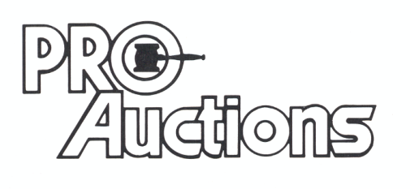 www.Proauctionsllc.com www.auctionzip.com
, LLC
RICK GARNHART, AUCTIONEER
German Valley, IL 61039
815-238-3044
IL Lic: 440000901 WI Lic: 2844-52

