HUGE FARM TOY AUCTION –1,000 PCS.
SAT. FEB. 28, 2026 10:00 A.M.
(STORM DATE: SUN. FEB. 29)
JANE ADDAMS COMMUNITY CENTER
430 W. WASHINGTON ST., CEDARVILLE, IL 61013
PREDOMINANTLY JOHN DEERE TOYS & COLLECTIBLES INCL:
50+ Assort. Precision J.D. Tractors; 150+ JD Tractors 1/16th; Big Bud 1/64th, NIB; 400+ 1/64th Tractors in Bubble Pack; JD: D,G,H,A,B,60,4010,40,420,520,820; Ford Precision SM, M, 2&3 B. Plow, 4000, 720, 730, Baler, Corn Planter; Oliver Precision: 77, 77 wf; AC Tractors NIB Precision : WC, WD45, WD; Assort. Summer Show Tractors: MM, Case, AC, IHC, Oliver; MH: 555, 101, 44, Pony, 55; 18+ Ford Tractors; IHC Crawlers; Cockshutt; Cat; MF; Deering; 15+ Case Tractors; Lawn & Garden: JD, Gravley, Kubota, Snapper, Ford, Cub Cadet; Iowa FFA Tractors; IHC Tractors, all types; Other 4x4 Tractors; AC Tractors NIB; IHC Historical Sets; IHC Historical Sets; 50+ JD Adv. Items & Promo’s; 4’ Cardboard JD Boy holding JD Tractor at Dealership; Structo Trucks; 15 Farm Country Sets, NIB; 8 Lawn & Garden Sets; 1/64th Semi Collection; Misc. Implements & Other brand Farm Toys; Old Wrench Collection; Boxes of Adv. Items & Literature; Ford & IHC Lawn & Garden Sets; Skid loaders NIB; Old Farm Magazines; Cast Iron Planter Lids; Lots of Stephenson County Engine Club Items & Plates; Hat Collection.
Note: Long time Collector from Freeport, IL has an outstanding collection of J.D. Toys, plus many other brands. Also many boxes full of advertising and literature! IMPORTANT: Be sure to go to websites to see pictures of these toys!

PREVIEW: 10 AM to Noon on Friday Feb. 27.
Terms: Cash or check w/ picture ID. Auction held inside w/ seating, restrooms & lunch available.
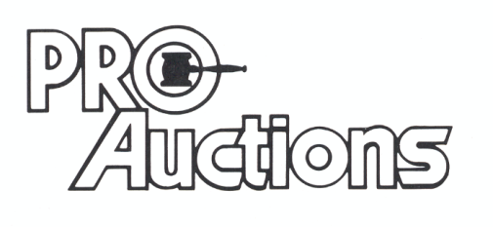
, LLC
www.Proauctionsllc.com www.auctionzip.com RICK GARNHART, AUCTIONEER 815-238-3044
German Valley IL 61039
IL Lic. #440000901 WI Lic. #2844-52

