HUGE FARM TOY AUCTION –1,000 PCS.
SAT. FEB. 28, 2026 10:00 A.M.
(STORM DATE: SUN. FEB. 29)
JANE ADDAMS COMMUNITY CENTER
430 W. WASHINGTON ST., CEDARVILLE, IL 61013
PREDOMINANTLY JOHN DEERE TOYS & COLLECTIBLES INCL:
50+ Assort. Precision J.D. Tractors; 400+ 1/64th Tractors in Bubble Pack; IHC Tractors, all types; Structo Trucks; 15 Farm Country Sets, NIB; 8 Lawn & Garden Sets; 1/64th Semi Collection; Misc. Implements & Other brand Farm Toys; Boxes of Adv. Items & Literature; J.D. Adv. Items; Cast Iron Planter Lids; Lots of Stephenson County Engine Club Items & Plates; Hat Collection.
Note: Long time Collector from Freeport, IL has an outstanding collection of J.D. Toys, plus many other brands. Also many boxes full of advertising and literature! IMPORTANT: Be sure to go to websites to see pictures of these toys!
PREVIEW: 10 AM to Noon on Friday Feb. 27.

Terms: Cash or check w/ picture ID. Auction held inside w/ seating, restrooms & lunch available.
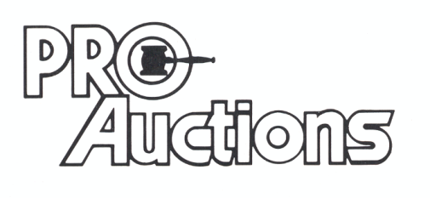
, LLC
www.Proauctionsllc.com www.auctionzip.com RICK GARNHART, AUCTIONEER 815-238-3044
German Valley IL 61039
IL Lic. #440000901 WI Lic. #2844-52

