HUGE FARM TOY & ARCADE TOY AUCTION – 450+ PCS.
SAT. JAN. 17, 2026 10:00 A.M.
(STORM DATE: SUN. JAN. 18)
JANE ADDAMS COMMUNITY CENTER
430 W. WASHINGTON ST., CEDARVILLE, IL 61013
250+ARCADE: Farm Toys; Penny Toys; Lead Soldiers. BRIAN SCHULTZ ESTATE, MONROE, WI: 75+ Collector Knife Collection; 50 J.D. Farm Toys; J.D. Prestige Tractors. FRANK BOLLMAN ESTATE, ROCK FALLS, IL: 1/8TH Oliver 1850 Tractor; 1/8th Oliver Flare Wagon; 1/8th Farmall 560; Oliver 70 Pedal Tractor; 75+ Other Farm Tractors; 200+ Bullet Pencils. HERSCHEL NEWCOMER ESTATE, OREGON, IL: J.D. Pedal Tractor 7930;
35+ Precision J.D. Tractors & Implements; 2 J.D. Snowmobile Suits; 7 Rare Carter Tru-Scale Manure Spreaders w/ orig. boxes.
Note: Many high quality Estate Toy Auctions. MANY items not listed! See websites for additional listings and pictures. Preview Friday 10-noon only. Terms: Cash or check w/ picture ID. Auction held inside w/ seating & lunch available.
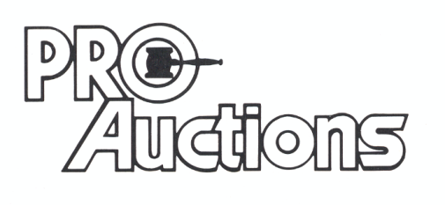 www.Proauctionsllc.com www.auctionzip.com RICK GARNHART, AUCTIONEER
, LLC
GERMAN VALLEY, IL 61039
815-238-3044
IL LIC: 440000901 WI LIC: 2844-52

