HUGE FARM TOY & ARCADE TOY AUCTION – 450+ PCS.
SAT. JAN. 17, 2026 10:00 A.M.
(STORM DATE: SUN. JAN. 18)
JANE ADDAMS COMMUNITY CENTER
430 W. WASHINGTON ST., CEDARVILLE, IL 61013
250+ARCADE-MONROE,WI: 6 IHC Threshing Machines; Oliver-Fordsen Tractors; Horse Drawn Spreaders; Assorted Implements; Horse & Wagons; IHC M; 50+ Penny Toys; Lead & Tin Soldiers; Watch Fobs; Stop Signs; Airplanes; Cream Separator; Trucks; Busses; Cars.
BRIAN SCHULTZ ESTATE, MONROE, WI: 75+ Collector Knife Collection; Muscle Cars; 1/64th JD Tractors; JD Prestige Tractors: 4450, 8R410, 4450, 4020, 620 w/ plow, 4255, 7520, 3020, 3600 plow, 7520, 4020 w/ loader, 4640, 8R370, 8400R, 3520, 7800; JD HO Train Set; Plus other JD; Case: 930, 1370, DC-3.
FRANK BOLLMAN ESTATE, ROCK FALLS, IL: 1/8TH Oliver 1850 Tractor; 1/8th Oliver Flare Wagon; 1/8th Farmall 560; Oliver 70 Pedal Tractor; Cockshutt Museum Series; T.F. Oliver 1950-T; T.F. JD 4230; JD 70HC; White 4-210 Gray Strip; White 2-135 Gray Stripe; 1st Gear Trucks ; IHC 1586; IHC 1026; 75+ Other Farm Tractors; Model Kits; 200+ Bullet Pencils-Ag. Advertising; Plus more items.
HERSCHEL NEWCOMER ESTATE, OREGON, IL: Rare J.D. Pedal Tractor 7930, WF, Freeport, IL Lawn & Leisure; 2 J.D. Snowmobile Suits; 7 Rare Carter Tru-Scale Manure Spreaders w/ orig. boxes. 35+ Precision JD NIB: Waterloo Boy, F145 Plow, Flat Rack, Barge Box, 3010, 630, 720w/ loader, 4440, 70 Wheatland, 494 planter, 214 T. Baler, 4020 w/
237 picker, 730, 4000 NF, WF, 70, A w/ cultivator, 110 L&G set, 5010 silver, 9420 T, B. unstyled.
OTHER J.D. TRACTORS: 4955, 6400, 7800, 8200, 8400, MX 120, 9300 T; FARMALL: 140,
STX 440, MX 240, MX 270, JD 8420T, JD 4430, JD 5020. 3 JD Jackets; BB Seed Bag; Arcade Coffee Grinder; Plus more.
Note: Four high quality Estate Toy Auctions. MANY items not listed including 100 1/64th toys. See websites for additional listings and pictures. Preview Friday 10-noon only. Terms: Cash or check w/ picture ID. Auction held inside w/ seating, restrooms & lunch available.

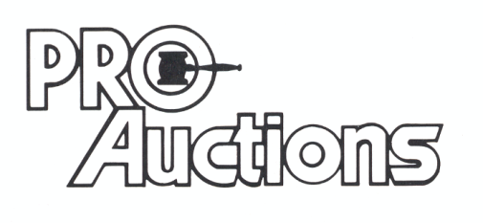 www.Proauctionsllc.com www.auctionzip.com RICK GARNHART, AUCTIONEER 815-238-3044
, LLC

w

