LARGE HOLIDAY TOY AUCTION
SAT. NOV. 15 10:00 A.M.
JANE ADDAMS COMMUNITY CENTER, CEDARVILLE, IL
FARM-CONSTRUCTION-OLD BARBIE DOLLS & ACCESSORIES + MORE:
JD 4020 Pedal Tractor w/ wf; J.D. 1/64th Toys; JD Precision Tractors; Max Armstrong H&M Tractor Set; 50+ Assort. Farm Toys & Tractors; AC Tractor; Structo Jeep Truck; Structo GarbageTruck; Structo Cement Truck; 1/64th Semi Collection; Rare ComEd 1/16th Truck; Lg. Amt. Nylint Construction Toys; Tonka Trucks; Texaco Tanker; Tin Marx Service Station; Erector Sets; Lionel Train Set; Model Car Kits; Match Box Toy; Nascar 1/64th Cars; 200+ 1/64th Hot Wheels, NIB; Arcade CI Animals; Tin Windup Toys; Lg. amt. 1960’s Barbie Dolls & Clothes for Barbie, Ken, Skipper etc; 3 Barbie Cases; Fischer Price Toys & Doll House; GI Joe Doll & Box; Tiny Teen Dolls; Peewee Dolls; Little Kido’s Dolls; Lg. Wooden Doll House; 50+ Sand Box Toys.
OLD LITERATURE-MISC: 500+Auto Sales Literature; 50+ Old Calendars; Sporting Items & Books; 50+ Prairie Farmer & Others; Toy Farmer Magazines; Boxes of Agriculture Literature; Tractor Manuals; Games; 5-cent Gum Ball Machine; True Value Bank Collection; Coors 3’ Beer Sign; Seed Corn Sign; Hercules Tire Sign; Record Albums; Hat Collection; Dick Tracy Items; Plus more!
Note: Lg. auction of Toys & Memorabilia. Be sure to check websites for good pictures!
Terms: Cash or check w/ picture ID. Auction held inside w/ seating, lunch and restrooms available.
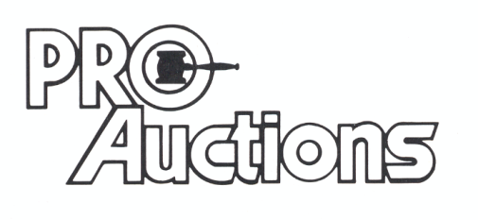 www.Proauctionsllc.com www.auctionzip.com RICK GARNHART, AUCTIONEER
, LLC
German Valley, IL 61039
815-238-3044
IL Lic: 440000901 WI Lic: 2844-52

