**HUGE FARM TOY AUCTION**

**SAT. OCT. 25 10:00 A.M.!**

**Preview: Friday Oct. 24 – 10 AM to Noon**

**RICH CAMPBELL COLLECTION, APPLE RIVER, IL**

**SALE HELD AT: JANE ADDAMS COMMUNITY CENTER**

**430 W. Washington St., Cedarville, IL 61013**

**400+ ALL COLORS, SIZES, & BRANDS**

**1/8 SCALE, NIB: 806 Pedal; IHC: Spreader, Flair Box, Disc, 400, SM, 1206, H, 856, 560, 806, 460, MD, 826 Gold, 450, SH, MTA, M; 1/12th: Oliver S99 w/ cat-Franklin; 1/16 IHC: K-5 Grain Truck, 1206 Wheatland, 1256 Wheatland, 1456 Wheatland, 21256 IND, 656 Gold, 544 w/ loader, 656, Cub, 806 NF, 1566, Farmall M, Mix-Mill, 826 Rops, 1086, 1586-Red Power, 1566 Black Strip, 400-Memorial, W450, 300LP, 3688, Plus more IH; JOHN DERE 1/16TH:**

**JD 5020 Precision Engineering Custom, 2-4020, 2-4010, 3010, 1010, 4255 HC, 4620 FWA, 9620, 2020 w/ blade, 3020 w/ loader, X485 Garden Tractor, 494 Planter, 145-H Plow, 4520, 6030, JD 4-set Card Board Buildings, 5010 w/ duals, 4020 Standard, 2010 w/ Disk, Plus other Implements; ALLIS CHALMERS: 6060 SFT, 1500 Chisel Plow, 2300 Sprayer, 2-220, 2-6080 FWA, D-19, AC 782 Forage Harvestor; OLIVER: S-88 W/ 74H Picker, S-77 HC, 1900 IND, 445 w/ Loader, 445 w/ Loader, 445 LP, 1950T, 1955, 2255, 1650, 1750, 770-880 Set; MM: G850, G940, G550, MMU w/ 3 B. Plow, 400 Planter; COCKSHUTT 1650 FWA; MF: 1100, 165, 1150 Triples, 936, 1156,9880; NH: TN75, 640, GT95, 8670, 8970, TV140, TC33DA, TJ375w/ Triples;**

**VERSATILE: 825, 935, 2000 Combine; FORD: 8360, 8340; PLUS OTHERS. 75+ Huge assortment 1/64 Tractors & Implements, all colors & Brands incl. 12 Big Buds, Steiger, CIH, Versatile, MF, JD, Ford.**

**CONSIGNMENT FROM MONROE, WI-TOY COLLECTION: Barber Greene Sand Loader, Tonka Flat Hauler; Model Toy Turn-A-Pull; Nylint Michigan Crane; MF98 w/ Loader; MH44 w/ wagon; Farmall 806; Oliver 1950 FWA, Kasten Forage Box; IHC: Forage Box; J.D.: 3020, 8130FWA, 5105, G,D; IHC: Hydro 70, 1256, 7150; AC: D-17, D-19, WD45, 7580, 440 4x4,**

**DA 9150; Plus others.**

***Note:* Extra large Auction of High quality Farm Toys, 98% NIB, all scales & sizes. Definitely one of best to be offered this year!**

***Terms: Cash or check w/ picture ID required. Auction held inside with seating, lunch & restrooms.* Check websites for many pictures.**

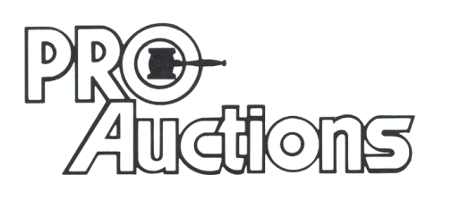

, LLC

[www.Proauctionsllc.com](http://www.Proauctionsllc.com) [www.auctionzip.com](http://www.auctionzip.com) **RICK GARNHART, AUCTIONEER**

**German Valley, IL 61039**

**815-238-3044**

**IL Lic: 440000901 WI Lic: 2844-52**