**LARGE ANTIQUE &**

**BEER COLLECTIBLES AUCTION**

**SAT. OCT. 4 10:00 A.M.!**

**MARLENE ATZ - FREEPORT, IL**

**SALE HELD AT: JANE ADDAMS COMMUNITY CENTER,**

**401 W. WASHINGTON ST., CEDARVILLE, IL**

**ANTIQUES & COLLECTIBLES: Red Wing Jugs; 3-5-6 Gal. Western Crocks; Red Wing Butter Churn; Crockery Bowls; 20+ Assort. Crocks; Rare Aunt Gemima S&P Set; Finger Lamps; Cookie Jars; Wood Adv. Boxes; Cookie Cutters; Lg. Planter’s Peanut Jar; Standard Oil Box; 50+ Assort. Milk Bottles; Big Little Books; Spatter ware; Many Aladdin Lamps; Butter Crocks; 2 Double Kerosene Globe Table Lamps; Ice Cream Table w/ 4 Chairs; Lamp Table; Child’s High Chair; 20+ Pcs. Blue & gray Granite wear-Pails, Tea Pots, etc; Milk Bottle Carriers; Pens & Pencils; Aladdin Floor Lamp; Brass Lamp; Wall Mt. Bracket Lamp; 12 other tall Chimney Lamps; Nascar items, cars, etc; 50+ Assort. Farm Toys; Cast Iron Barn & Animals (Hands Court); Murry 2 T. Pedal Tractor; Blue Jeep Pedal Car; 2 Oscar Mayer Weiner Mobiles; Pepsi Cola Items; Coca-Cola Adv. Items; 2 Hanging Parlor Lamps, ornate; Firestone Tire Sign; Interstate Battery Sign; Costume Jewelry; Boxes Record Albums & 45 records; 15 Soakeys Algate Bottles; ICCR Signal Light, Sign; 15+ other RR Lights (Dietz, Adams); Forreston Bank Adv; True Value Bank Collection; Phillips 66 Globe; Oak Brand Ice Cream Tray; Plus more.**

**30+ BEER ADVERTISING SIGNS, SOME LIGHTED: Schlitz Beer, lighted; Jack Daniels, lighted; 2 Budweiser w/ horses; Hamm’s, lighted; Olympia; Falstaff; Pilsen; Milwaukee; Bud Light; Lite; Matilda; Coors; Hamm’s; Pabst.**

**24 BEER MIRRORS: Seagram’s; Old Milwaukee; New Glarus; Nordic Wolf; Miller High Life; Miller Wolf; Miller Black Bear; Miller Pheasant; Pabst Deer; Pabst Wolf; Pabst Wood Duck; Pabst Extra Light; Budweiser Clydesdale; Molson; Coors 26x20 Sign; Coors Buffalo; Coors Big Horn; Coors Timber Wolf; Gennis Lighted on stand; Small Kegs & Beer Tapper; Assort. Openers & Tappers; Plus other Beer related items. *Note: High quality, good primitive collectibles, unique variety.***

***Terms: Cash or check w/ picture ID required. Auction held inside with seating, lunch & restrooms.* Check websites for many pictures.**

[www.Proauctionsllc.com](http://www.Proauctionsllc.com) [www.auctionzip.com](http://www.auctionzip.com) **RICK GARNHART, AUCTIONEER**

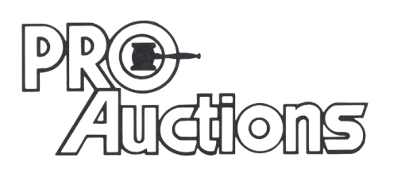

, LLC

**German Valley, IL 61039**

**815-238-3044**

**IL Lic: 440000901 WI Lic: 2844-52**