**LARGE TOY AUCTION**

**SAT. MAY 3 10:00 A.M.**

**JANE ADDAMS COMMUNITY CENTER**

**430 W. WASHINGTON ST., CEDARVILLE, IL**

**HARRY BOWEN COLLECTION (Orangeville, IL) – 300+ PCS:**

**6+ Smith Miller: Pie Semi, Blue Diamond Freight Truck, Hook & Ladder Fire Truck, White Wrecker; 1930’s Keystone Dump Truck; 2 Model Milwaukee Fire Trucks; Model Road Grader; Nylint Payloader; Buddy L Coca Cola Truck; Erector Set/Red Box; Nylint Good Year Semi; Nylint Clauson Pickle Truck; Nylint Deans Milk Truck; Structo Freight Truck; Fairway Express Truck; IHC: K-B5 Wrecker NIB, 1206 w/ white fenders; Kent Feed Truck; Texaco Truck; Structo H&L Truck; Wyandotte Freight Truck; Structo Cattle Hauling; Milwaukee AC-C; MF: 1100, 33, 44, Pony, 4x4, 1150; JD A High Post; 1900’s Brass Steam Engine; Green Co. IHC 340 w/ Planter; Reuhl Combine; Reuhl 44 MH; White 2-135; White 2-155; Rare Stephen Model MH 44 (Beloit, WI); Other MH & MF Tractors; Handmade models by Leroy Unger of Monroe, WI (40 yrs old): Oil Pull, Reeves, Titan, Case, Holt Crawler; Handmade 1/16 model Farm Bldgs Collection of the Bowen Farmstead by Wilbur Kruse: Oliver 2255 custom; Cockshutt 1950-T FWA; Oliver S-99, 990, 770; MF 98; IHC MTA-wf; MM U-wf; MH 555, 55; Oliver 88 w/ cultivator; JD G, 720; 2 IHC TD 24 Crawlers.**

**SMALL COLLECTION TOYS, APPPLE RIVER, IL-40+ NIB: Battery Powered: Cat Dozer, Loader, Excavator & Truck; CIH: MX 240, 2594, 2-7120; IHC: 1586, 460 Precision, 300 HC, 504, 1456, 340 Crawler, 8-16 gray & green, 756, 1206, F-12, 400; JD: 630 Precision, 430 Dealer, 330, 430 Crawler; MM 850 & G940.**

**14 HIGH QUALITY OLD SIGNS: Hawthorne-Mellody Milk; Critic Feed; Kent Feed; 1939 Dekalb Fiber Seed Corn; Rochester Silo; Interstate Battery; Biddick Hybrid; Mueller Sign; Sears Farm Master; NFO; Wendnagel Bridge Sign; Minneapolis Water Bag; Piedmont Cigarette.**

***Note: Large sale of high quality Farm Toys, Construction, Trucks & Signs. Go to websites for pictures. Call auctioneer for information. Preview Friday 10-noon and one hr. prior to sale.***

***Terms: Cash or check w/ picture ID required. Auction held inside with seating, lunch & restrooms.* Check websites for many pictures.**

[www.Proauctionsllc.com](http://www.Proauctionsllc.com) [www.auctionzip.com](http://www.auctionzip.com) [www.auctionlook.com](http://www.auctionlook.com)

**RICK GARNHART, AUCTIONEER**

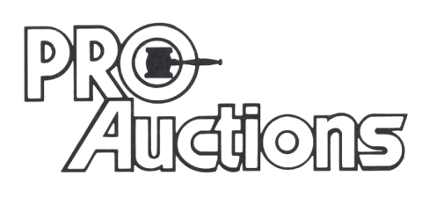

, LLC

**German Valley, IL 61039**

**815-238-3044**

**IL Lic: 440000901 WI Lic: 2844-52**