**HUGE FARM TOY AUCTION**

**SAT. AUGUST 9 10:00 A.M.!**

**(Open House: Friday August 8th, 10:00-Noon)**

**Vernon Johnson Collection, Kirkland, IL**

**JANE ADDAMS COMMUNITY CENTER**

**430 W. Washington St., Cedarville, IL 61013**

**700+ LARGEST COLLECTION IN NORTHERN ILLINOIS!**

**TRACTORS & IMPLEMENTS: Rare JD 7520 & yellow Gang #220 Disk; JD: 8650, 9620, 4430, 9220, 8640, 2010, 2440, 6400, 2510, 3010, ; JD Combine; JD 820 Trumm; JD 60 w/ loader; JD 110 Mower; JD 4230 Custom; JD 4440 Custom; 2- JD precision 4020; JD 4320 Krominga Custom; JD G Freiheit Tractor Custom; Orion Samuelson F-20; Max Armstrong IHC H&M Set; JD 4010-3010 T.F.T.S.; JD Yellow Scraper; MM LP Tractor-Hooker; IHC TD24 Crawler, remote; Robert Gray AC Regular; MM UB Tractor; Holthmans MM w/ 4 R. Cultivator;**

**IHC: 1566, Wing Disk, Cub Tractor, Loadstar Truck, 400, 450, 340, 560, 5088, Yellow Cub w/ blade; IHC 560 w/ 3 B. Plow; 40 Pcs. True Scale; Product Miniature Ford; Product AC; Custom Parker, Kill-Bros, DMI Wagons; Slik MH Spreader; Slik MH 44; Monarch Case DC; Case 930; NH Grinder Mixer; Reiche 3 B. Plow; 100+ Assort. J.D. Implements, etc. OLIVER: Slik Combine, 1 R. Picker, Baler, Manure Spreader, Flair Wagon. PEDAL TRACTORS: Case 800; Farmall M; John Deere. ALL VERY SHARP! BUILDINGS: Roy Rogers Marx Set w/ horses; T-Continental Airport Set & Gas Station by Marx; Marx R.R. Station & Depot; Cheyenne Western Set.**

**ARCADE-TRAINS-TRUCKS-OTHER: Arcade Cook Stove; Arcade Threshing Machine; Lionel Union Pacific Train; Lionel Train Set w/ Coal Loader, Search Light, Milk Can Loader; Nylint Trucks; Buddy L Trucks; Tonka Bull Dozer; Franklin Mint & Danbury Cars & Trucks; Deans Semi Truck; Tonka Allied Van Semi; Blue Stake Truck; Gasoline Truck; Struck Crane; DeKalb Seed Corn Semi Truck; Dunwell JD Semi; Other Assort. Cars & Trucks; Match Box Collection;**

**75+ Tootsie Toy Collection.**

***Note:* Rare opportunity to purchase many hard to find toys! Vernon collected, restored and did toy shows. Many items not mentioned. Be sure to see pictures on websites. We are honored to offer his amazing lifelong collection.**

***Terms: Cash or check w/ picture ID required. Auction held inside with seating, lunch & restrooms.* Check websites for many pictures.**

[www.Proauctionsllc.com](http://www.Proauctionsllc.com) [www.auctionzip.com](http://www.auctionzip.com) [www.auctionlook.com](http://www.auctionlook.com)

**RICK GARNHART, AUCTIONEER**

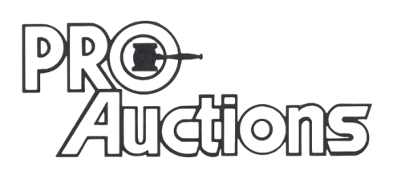

, LLC

**German Valley, IL 61039**

**IL License: 440000901 WI License: 2844-52**