**HUGE FARM TOY AUCTION**

**SAT. JAN. 25 10:00 A.M.!**

**(STORM DATE: SUN. JAN. 26)**

**JANE ADDAMS COMMUNITY CENTER**

**430 Washington St., Cedarville, IL 61013**

**300+ PCS, MANY OLD & NIB: JD: Rare 7520 4x4 Tractor w/ yellow JD 220 Disk, 9860 Combine, 8410, 8400T, 9650 4x4, 494 Planter, Waterloo Boy-Employee, 6 B. Plow, 5020, 3 pt. 4 B. Plow, 6000-7000 Demonstrator, 7800 FWA, 8400 FWA, 70 w/ Loader, orig, 720 H.D., GP; 1960’s Dick Tracy Car w/ box; 1960 JD 4010 w/ orig. box; 1960 IHC 560 w/ orig box; 1960 JD mtd. Picker w/ orig box; 1960 Oliver 880 Slik; 1960 Oliver 1800 Checkerboard; 1960 JD Loader; White**

**2-155 Gray stripe; 2 IH 7 B. Plows; 3 1/64th Big Bud; Bantan C-35 Shovel NIB;**

**T.T. Spirit 76 NIB; IHC 806; IHC 1206; Hubley Dozer; Ford Hubley Tractor w/ post auger; JD PRECISION:** **4000, 4010, 3010, 4020, A Steel, A Rubber; 4020 P.S. ,**

**154 Plow; Orig. JD 12A Combine; Model Toy Pan Scraper, Milwaukee; 3 Radio Control Ski-Doo Snowmobiles, 1/40th scale w/ box; Field of Dreams 2640; STRUCTO: Dump Truck, Machinery Hauler, Sand Loader w/ box, Cement Mixer w/ box; T.S.: Bronco w/ Snow Plow, Picker, Rake, Plow, Disk, 560 w/ loader;**

**2 Chad Little J.D. Race Cars; J.D. #97 Dealer Ed Car; 1907 J.D. Clark Car; J.D. Chad Little Transporter Race Car; J.D. Gold Medallions; 4 J.D. Gold Belt Buckles; 4 Pc. J.D. Canister Set; J.D. Collector’s Plates; 15+ Boxes full of assort. Literature, adv. Items, magazine cuts, local paper, adver items, calendars, etc; 1,000+ pcs. Rare paper.**

***Terms: Cash or check w/ picture ID required. Auction held inside with seating, lunch & restrooms.* Check websites for many pictures.**

[www.Proauctionsllc.com](http://www.Proauctionsllc.com) [www.auctionzip.com](http://www.auctionzip.com) [www.auctionlook.com](http://www.auctionlook.com)

**RICK GARNHART, AUCTIONEER**

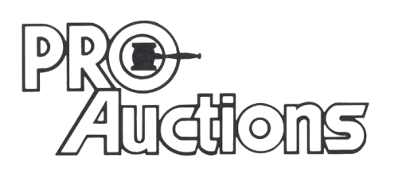

, LLC

**German Valley, IL 61039**

**815-238-3044**

**IL Lic: 440000901 WI Lic: 2844-52**