**HUGE ANTIQUE TOOL & SEED CORN ITEMS**

**AUCTION**

**SAT. JUNE 7 10:00 A.M.!**

**“PAUL DEETS ESTATE”, MILLEDGEVILLE, IL**

**JANE ADDAMS COMMUNITY CENTER**

**430 W. WASHINGTON ST., CEDARVILLE, IL**

**UNUSUAL OFFERING OF 1,000+ ANTIQUE CAST IRON FARM IMPLEMENTS & SHOP TOOLS (ALL POLISHED, MANY RARE & W/ EMBOSSED NAMES!) FOLLOWING IS A VERY SMALL LIST OF THIS 70 YR. COLLECTION.**

**FARM RELATED ANTIQUE ITEMS: ASSORTED PULLEYS; 50+ HAMMERS & MAULS; WOOD BITS & BRACE; CHEESE BOXES; JD WATER PUMP; CIGAR BOXES; FORKS, SHOVELS, RAKES; WOOD PLANES; OIL CAN COLLECTION; TOBACCO TINS; HARNESS ITEMS; AXE COLLECTION; HAND OPERATED FORGE; DRAW KNIVES; 75+ MTD. TOOLS ON PEGBOARD; BRASS SCALE; BRASS SCALE BEAM;G ILBERT CHILDS TOOL BOX; 7 DEKALB DINNER PLATES; 1,000. MTD. BULLET PENCILS & PENCIL COLLECTION; EGG BASKETS; MINIATURE TOOLS; APPLE PEALER; JD TOOL BOX; PENCIL COLLECTION MTD. ON BOARD; SILO WRENCHES; PLUS MORE OLD TOOLS.**

**SEED CORN RELATED ITEMS: 4’X6’ SEED CORN DRYER RACK; SEED CORN DRYERS; CORN PLANTER STAKES; 5 HAND CORN SHELLERS; 2 HOLE CORN CUTTER; 200+ CAST IRON CORN PLANTER PLATES; JD #1 HAND SHELLER; 100+ HOOKS, PEGS, & HAND EAR CORN PICKER ITEMS; TIN SIGNS; BLACKHAWK SEED CO. POLO LICENSE TOPPER; GOLDEN HARVEST JARS; 100+ SEED CORN PLASTIC ADV. BAGS; PLANTER LIDS: JD, OLIVER, CASE, BLACKHAWK, COOP, BRADLEY, MANSEUR; 37 SAMPLE SEED CORN BAGS: DEKALB, PIONEER, RENK, FUNKS; SEED CORN PITH HELMET; HAT COLLECTION; 1,000+ SEED CORN POCKET BOOKS; STOCK YARDS ADV. ITEMS; CAST IRON PLANTER BOX LIDS: IHC, DEERE, FORD, HAYS, GALE, BLACKHAWK; CAST IRON ADV: MOLINE PLOW, MAYTAG, STERLING, J.I. CASE; YARDSTICK COLLECTION; PLUS MORE TO BE UNPACKED.**

***Terms: Cash or check w/ picture ID required. Preview Friday 10-Noon. Auction held inside with seating, lunch & restrooms.* Check websites for many pictures.**

[www.Proauctionsllc.com](http://www.Proauctionsllc.com) [www.auctionzip.com](http://www.auctionzip.com) [www.auctionlook.com](http://www.auctionlook.com)

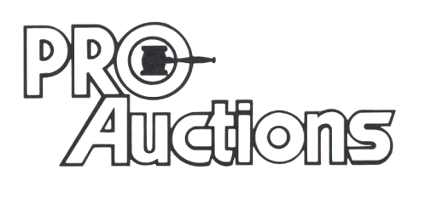

, LLC

**RICK GARNHART, AUCTIONEER**

**German Valley, IL 61039**

**815-238-3044**

**IL Lic: 440000901 WI Lic: 2844-52**