**ANTIQUE SIGNS-CAST IRON SEATS-FARM TOYS**

**SAT. OCT. 12 9:30 A.M.**

**JANE ADDAMS COMMUNITY CENTER**

**430 W. WASHINGTON ST., CEDARVILLE, IL**

**20+ SIGNS: Posted No Hunting; WI Agriculture; Farmer’s Union; Prairie Farmer; Cappers Farmer; IL Farm Bureau; Butter & Eggs; CFS Fertilizer; Wallace Farmer; Feed Sign; Other Seed Corn Signs. 20+ CAST IRON & TIN SEATS: Rock Island; Furst & Bradley; Rockford; Grand Detour; McCormick; Milwaukee; JD Planter Seat; Brattley; George W. Brown; Deere Mansuer; Parlin & Odendorf; Others. FARM TOYS, 90% NIB: Oliver: 77, S77, 77HC, 770, 880, Mist Green 880, 990, 1950, 1855 red & green, S88, 60 puller, 70, 1650, 1750, 1800 checkerboard w/ NI loader ; White American Set “60” Rops NIB; White 5400 Planter; Hart Parr 80; John Deere: Toy Farmer 4010, Early Manure Spreader, Crawler, Precision Barge Box, Precision A, 4010. Cockshutt 770; AVCO Round Baler; AC Wing Disk; Ford Wing Disk; M.M. 5 Star; M.M. U; Great Plains Drill; Cockshutt 1855; Lg. amt. 1/64th; 25+ sm. Tin Cars & Trucks; Plastic Cars & Trucks & Animals; Cardboard Buildings; Greyhound 1950 Blue Coaster Wagon-super cond!; 12+ Win Ross Semi Trucks NIB; Plus numerous other Farm Tractors to be unpacked.**

**LITERATURE-PAPER (50+ flats full) 50+ Coca-Cola Pictures; 1950 10-cent Western Dell Comic books (15); Case Farm Machinery ads; R.R. Ads & Collectibles; Florence Station Toy Catalog; Structo Adv; 500+ Agriculture & Farm Ad Clips; Automobile Ad Clips; Plus more by sale. Day.**

***Terms: Cash or check w/ picture ID required. Auction held inside with seating, lunch & restrooms.* Check websites for many pictures.**

[www.Proauctionsllc.com](http://www.Proauctionsllc.com) [www.auctionzip.com](http://www.auctionzip.com) [www.auctionlook.com](http://www.auctionlook.com)

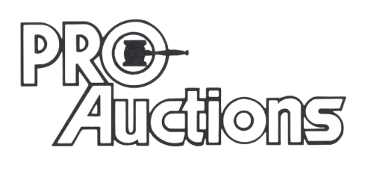

, LLC

**RICK GARNHART, AUCTIONEER**

**German Valley, IL 61039**

**815-238-3044**

**IL Lic: 440000901 WI Lic: 2844-52**