**LARGE FARM TOY AUCTION**

**SAT. SEPT. 14 9:30 A.M.**

**JANE ADDAMS COMMUNITY CENTER**

**430 W. WASHINGTON ST., CEDARVILLE, IL**

**350+ FARM TOYS and 200+ 1/64th SEMI TRUCKS, NIB INCL: 1/16TH JD, Oliver, TS, IHC Tractors & Implements; 4x4 Tractors; Custom Implements; Forreston FFA Tractors; Oliver Walking Plow, excellent!; JD-MCI Crawler, Dalton, Minnesota; Oliver 770, 77,1850, etc; Custom Oliver 73 Pull Picker; Big Bud 1/32nd 500, 440; JD A w/ Cultivator; Oliver & Case Plows; Ford Disk; White American 60; MH Literature; White L&G Paper; AGCO Literature; 50 Boxes full of Tractors, Trucks, Cars, Farm related Literature; Magazine Ad Cuts; Plus other numerous Farm Toys.**

***Terms: Cash or check w/ picture ID required. Auction held inside with seating, lunch & restrooms.* Check websites for many pictures.**

[www.Proauctionsllc.com](http://www.Proauctionsllc.com) [www.auctionzip.com](http://www.auctionzip.com) [www.auctionlook.com](http://www.auctionlook.com)

**RICK GARNHART, AUCTIONEER**

**German Valley, IL 61039**

**815-238-3044**

**IL Lic: 440000901 WI Lic: 2844-52**

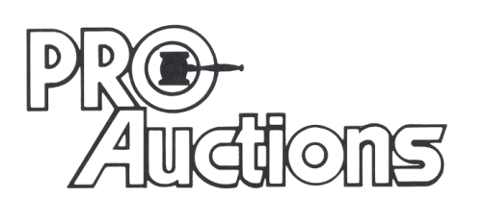

, LLC