**ANTIQUE AUCTION**

**SAT. NOV. 9 10:00 A.M.**

**(RAIN DATE: SUN. NOV. 10)**

**WM. “BILL” HEROLD ESTATE**

**65 IL RT. 73 S. PEARL CITY, IL 61062**

**ANTIQUE FURNITURE-COLLECTIBLES: Jenny Lind Brass Bed; 1900 Fancy Carved Oak Bedroom Set w/ Chest drawers; Oak Commode w/ T Bar; Treadle Sewing Machine; Flower Table; Oak Plant Stand; Lots Crocks & Jugs; Red Wing; Doll House; Kitchen Cupboard;**

**6 Pressed Back Chairs; Drop Leaf 5 leg Table; Bracket Lamp; Wood Bowls; Square Oak Table; Standard Wear Corn Pottery; 6’ Pine Cupboard; School Bell; Small Showcase; 6’ Glass Showcase; Wicker Child’s Rocker; Dolls; Mantle Clock; Rare Lg. Red Wing Water Cooler; Oak Wall Phone; Smokers Stand; Oak Rocker; Oak Frames; Freeport & local Adver. Items; Boxes full of Adver. Literature; Boxes full of Farm Toy Parts; 3 Wagons full of assort. Misc. Literature, Paper & Collectibles; Plus many boxes to be unpacked.**

**SHOP-WOOD WORKING TOOLS: Small Eastman Sand Blaster; Pedestal Grinder; Dremel Saw; 12” Lathe; Metal Cut off Saw; Hand Corn Sheller; Lawn & Garden Tools; Chain Hoist; Hand Tools; Air Tank; Battery Charger; Sears Air Compressor; Alum. Ext. Ladder; Waterloo R.A. Tool Box; Drill Press; Delta Band Saw; 4 ½” Jointer/Planer; Wood Clamps; Sanders; Floor Jack; Lawn Sprayer; 3-Light R.R. Light; Plus more!**

***Note: Large auction of quality Furniture and Tools. Bill collected and sold at steam and toy shows for 40 years and was well known for his knowledge and attention to detail. Many items not listed, still to unpack.***

***Terms: Cash or check w/ picture ID.***

[www.Proauctionsllc.com](http://www.Proauctionsllc.com) [www.auctionzip.com](http://www.auctionzip.com) [www.auctionlook.com](http://www.auctionlook.com)

**RICK GARNHART, AUCTIONEER**

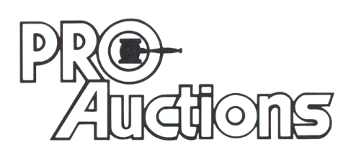

, LLC

**German Valley, IL 61039**

**815-238-3044**

**IL Lic: 440000901 WI Lic: 2844-52**