**ADVERTISING & MEMORABILIA AUCTION**

**SAT. AUG. 17 9:30 A.M.**

**(VIEWING OF TOYS FRIDAY AUG. 16 FROM 10 AM-NOON, OR BEFORE SALE 8 AM)**

**4TH sale for “Marv” Rufi Estate, Monroe, WI**

**Auction held at: Jane Addams Community Center,**

**430 W. Washington St., Cedarville, IL 61013**

**MONROE, WI & GREEN COUNTY ITEMS: Full set Cheese Days Butters; Post Cards; Beer Adv; Milk bottles; Posters Old Events; Yard Sticks; Rulers; Pens Pencils; Local Business Items; Souvenir pcs. from Green Co. & History Items; Books; Medicine Bottles; Adver. Cards; Business Giveaways; Wood Boxes; Cheese Related items; 50 boxes to unpack! 100’s items too numerous to mention!  *Note: This 4th Auction is unusual in that it is entirely advertising collectibles of the Green County, WI area. All items again in superb condition. Be sure to see the pictures on the websites. A wide variety of items to offer. You will be amazed!***

***Terms: Cash or check w/ picture ID required. Auction held inside with seating & restrooms and lunch.***

[www.Proauctionsllc.com](http://www.Proauctionsllc.com) [www.auctionzip.com](http://www.auctionzip.com) [www.auctionlook.com](http://www.auctionlook.com)

**RICK GARNHART, AUCTIONEER**

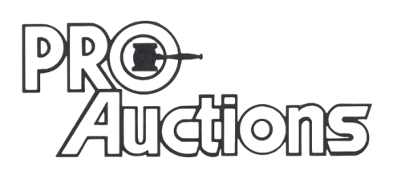

, LLC

**German Valley, IL 61039**

**815-238-3044**

**IL Lic: 440000901 WI Lic: 2844-52**