**HUGE OLIVER/WHITE FARM TOY AUCTION**

**SAT. OCT. 26 9:30 A.M.**

**Craig Montgomery Estate – Monroe, WI**

**Auction held at: Jane Addams Community Center,**

**430 W. Washington St., Cedarville, IL 61013**

**600+ HIGH QUALITY OLIVER/WHITE TOYS & OTHERS – 80% NIB**

**Oliver-White: 4-270 4x4, 4-210 4x4, 4-225 4x4, 10 Oliver Crawlers, Cletrac Crawlers; Cockshutt 1900 w/ Firestone Planter; White-American 80 FWA-ROPS (green, yellow, red, silver); Plainsman A4T-1400; 8 Cockshutt Museum Series; Arcade 70; Many Show Tractors incl: 12 Forreston Show,5 Mark Twain, 5 Toy Tractor Times, NFTM, Lafayette, HPOCA; Monroe Cheese Days #1-6 Tractors; Lg. amt. 1/64th Olivers; 2 Precision S-77 Red & Green wheel; White/American Cab Series; 1800-1/8th Checkerboard; 1850 Pink 1/8th; Flair Wagon 1/8th; Custom made Implements incl: Plows, Planters, Harvestors, Wagons, Spreaders, Combines, Grinder/Mixer, Gravity Boxes, Pulling Tractors; Franklin Mint S-99; Hart Parrs; 2050 Puller; Assort. 2-3 Bottom Plows; 200+ Oliver 66, 77, S77, 88, S88, 770, 880, 1600, 1650, 1750, 1755, 1855, 1950, 2255, etc; MM: G750, 940, 550, 750 4x4; Plus many more Tractors & Implements.**

**OTHER FARM TOYS & MISC: JD: 4010, 3010, 6400; NH 8970, 8570; Titan STR 36D; T.S. Implements; Toy Farmer 1/32 Scale Series: IHC 4366, IHC 4786, Case 4890, Massey 1500, IHC 3788, Steiger Panther Tiger, JD 8650, Case 2470, AC 7580, Versatile, Assort. Toy Farmer 1/64th Series; 1/64th Semi Trucks; 2 Microswitch 1/16 Trucks; JD L&G Set; Tractor Literature Manuals; 4’ & 8’ Glass Show Cases; Assort. Clocks & Adv. Items; Surge Milker Pails; Plus much more!! *Note: Craig collected Oliver/White Toys & Tractors for 50+ yrs. Rare opportunity to purchase high quality toys. Everything in superb condition! Many, many items not listed.***

***Terms: Cash or check w/ picture ID required. Auction held inside with seating & restrooms.* Check websites for many pictures.**

[www.Proauctionsllc.com](http://www.Proauctionsllc.com) [www.auctionzip.com](http://www.auctionzip.com) [www.auctionlook.com](http://www.auctionlook.com)

**RICK GARNHART, AUCTIONEER**

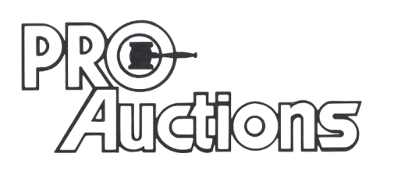

, LLC

**German Valley, IL 61039**

**815-238-3044**

**IL Lic: 440000901 WI Lic: 2844-52**