**LARGE TOY & TRUCK AUCTION**

**SAT. JULY 13 9:30 A.M.**

**JANE ADDAMS COMMUNITY CENTER**

**430 W. Washington St., Cedarville, IL 61013**

**DWIGHT ZETTLE ESTATE, BROADHEAD, WI: IHC: 1456, 340 w/ plow, A,B,C, 656 Prestige, Grinder Mixer, SMTA, 100 Hydro, IHC Implements, 450 Puller; JD: 8210 Tractor, 4010 HC, LA, MT, 4670 Prestige, 4430 Prestige, 5105, 320-420 box, 520-620 box, 8420 Track, 9500 Combine, 420 w/ Disc, 40-70 box, 50-70 box, 6R. Planter, 620 HC, 4010 HC, 55 Plow, 330 w/ Hay Rack; Oliver 1850; Case: D, DC, DC LP; Plus Others. GARRY & GLORIA SIGNER , MONROE, WI (100% JD COLLECTION): Inc. 25+ Combines NIB-S790 Combine Prestige, S690 Combine Prestige, 55 Combine Prestige, 7720 Combine, 9670 Farm Show , 9860 Combine, 9760 Combine, 7720 Titan II, 9600 w/ heads; JD Tractors: 630 w/ mtd Picker, 60 Picker Sheller, 9570 RX, Silver 9620, 4620 Prestige, 9470 RX, 9400T, 9620 RX Collectors; 8430T Collectors; 7 JD Prints; Misc JD Collectibles; JD Pocket Knives; White 2-135 Davis, Imp .PAUL FOX ESTATE, LENA, IL: 150+ 1/64TH Semi Trucks, all types. Many local Companies NIB – 25+ Structo Trucks & Misc; Fire Truck Collection; 7+ JD Precision Tractors & Implements. BILL HEROLD COLLECTION, PEARL CITY, IL: 20+ Boxes of Agriculture, Auto, Farm Literature & ad cuts; Tractor & Truck Manuals; Other Rare Adver. Items. *Note: Large auction w/ variety of good Farm Toys & 1/64th Semi Trucks. 3 tables full of sm. Cars & Trucks, plus Misc. Items.***

***Terms: Cash or check w/ picture ID required.***

***Auction held inside w/ seating, Lunch, and restrooms.***

**Check websites for many picture**s. [www.Proauctionsllc.com](http://www.Proauctionsllc.com) [www.auctionzip.com](http://www.auctionzip.com) [www.auctionlook.com](http://www.auctionlook.com)

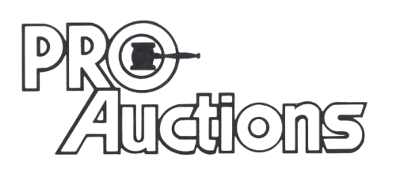

, LLC

**RICK GARNHART, AUCTIONEER**

**German Valley, IL 61039**

**815-238-3044**

**IL Lic: 440000901 WI Lic: 2844-52**