**HUGE FARM TOY MUSEUM AUCTION**

**SAT. JUNE 1 9:30 A.M.**

**(VIEWING OF TOYS FRIDAY MAY 31, 10 AM-1 PM, OR BEFORE SALE 8 AM)**

**“Marv” Rufi Estate, Monroe, WI**

**Auction held at: Jane Addams Community Center,**

**430 Washington St., Cedarville, IL 61013**

**600+ FARM TRACTORS & TRUCKS INCL. IHC, JD, AC, MOLINE, CASE, & ARCADE**

**IHC: 1/16 Display 4’x8’ IHC Dealership Building; IHC 2+2, 3588, 7488, 6286, Cub, A, M, TD25, 3-560, 1206 Key Series, 806 w/ picker, Early IHC Spreader, Disk, Elevator, Full Series IHC A, 3’x3’ lighted IHC Sign from Dealership. JD: A, R, D, 830, 720, 620, M, 5020, 720 H.C., Early 60 w/ loader; Early 60 w/ picker, 4020, Waterloo Boy, Custom Grinder, 40-70 w/ box, 50-60 w/ box, IND R, Precision 40 w/ 2 B. Plow; JD 145 Plow, 10+ Rumley oil pull Tractors; Rail Car w/ 3 Rumleys; 5 Wood oil Pulls. CASE: 600, 800, 1030, 1070, 1170 BK, 500, DC, VAC, 3 Steam Engines #Heritage, Baker, Avery, Mamod. 1/8 SCALE TRACTORS: MM 44; 2-JD A; JD D; Oliver 1850; IHC M w/ wagon; IHC 550; IHC Gold 826; Kinzie 1050 Grain Cart. PEDAL TRACTORS: AC; Case; JD 60, steel seat; IHC 400; JD A; Oliver 88 closed side; IHC 5,000,000th 1066; IHC 560 Eska; IHC 856. 10+ ASSORT. ARCADE TOYS: 3 Sets Wagon & Horses; Threshing Machines; Arcade Imp. + more.**

**SMITH MILLER TRUCKS: Sinclair Gas; Mobil Gas w/ Pup Tractor; SM Fire Hook & Ladder Red; SM Fire Hook & Ladder White; Road Star; Land “O” Lakes; Sunoco & Pup Tractor; Hostess Cake; Freight Hauler; NAVAJO; Brunswick; US Army; Borden; Milk Tanker; Trans Continental; Yellow Log Hauler; Standard Oil Co; Bekins VanLines; Indian Motor Cycle; Gray VanLines; P.I.E. Trucking; Plus more. Note: Gigantic auction of superb quality toys-1st of 3 auctions. Many custom toys. Rare pedal tractors & cars. Please note some of the pictures on the websites may appear on any of the 3 scheduled auctions. Many items too numerous to list.**

***Terms: Cash or check w/ picture ID required. Auction held inside with seating & restrooms.***

**Check websites for many pictures.** [**www.Proauctionsllc.com**](http://www.Proauctionsllc.com)

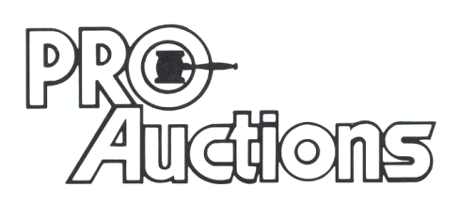

, LLC

**Auctionzip.com auctionlook.com**

**RICK GARNHART, AUCTIONEER**

**815-238-3044**

**IL Lic: 440000901 WI Lic: 2844-52**