**HUGE FARM TOY MUSEUM AUCTION**

**SAT. JUNE 29 9:30 A.M.**

**(VIEWING OF TOYS FRIDAY JUNE 28, 10 AM-12 PM, OR BEFORE SALE 8 AM)**

**2nd sale for “Marv” Rufi Estate, Monroe, WI**

**Auction held at: Jane Addams Community Center,**

**430 W. Washington St., Cedarville, IL 61013**

**500+ FARM TRACTORS & TRUCKS: 7 Pedal Tractors incl. JD, IH, Oliver, MM; Tin Signs; JD, Oliver, MM, Case, IHC, etc Tractors & Implements all makes; 40+ Smith/Miller Trucks & Trailers; 25+ Early Tonka Trucks; Buddy L, Structo etc; 1960’s Tonka Trucks & Trailers; Huge amt. of other Trucks; Custom Farm Implements; Custom Steam Engines; Oil-Pull items; Gas Engine Models; Custom Corn Pickers & Tractors; Custom Pulling Sled, 1/16th; IHC Rake w/ Horses; Wood IHC Box & Horses; Knapheide Wagon & Horses; Steel IHC Thresher; Automated Wood Steam Engine; Franklin Mint: Case DC, AC, Oliver S-99, Ford 8N, IHC H, F-20; Aultman Taylor Engine; Orange State Highway Set; Green State Highway Set; Custom Oil Pull w/ Buzz Saw; Custom Oil Pull w/ Saw Mill; Several Sm. Show Cases; Lots small Souvenir pcs. & Collectibles; Other good Trucks & Tractors; Plus much more to be unpacked from storage units! *Note: The 2nd extraordinary auction for this estate! ALL items are superb quality. Another rare opportunity to obtain highly desired and custom made toys. Don’t miss! Many items not listed. Terms: Cash or check w/ picture ID required. Auction held inside with seating & restrooms.* Check websites for many pictures.**

[www.Proauctionsllc.com](http://www.Proauctionsllc.com) [www.auctionzip.com](http://www.auctionzip.com) [www.auctionlook.com](http://www.auctionlook.com)

**RICK GARNHART, AUCTIONEER**

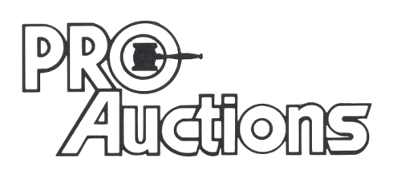

, LLC

**German Valley, IL 61039**

**815-238-3044**

**IL Lic: 440000901 WI Lic: 2844-52**