**LARGE FARM TOY AUCTION**

**SAT. MARCH 16 9:30 A.M.!**

**JANE ADDAMS COMMUNITY CENTER**

**430 Washington St., Cedarville, IL 61013**

**500+ FARM TOYS & IMPLEMENTS FROM AREA CONSIGNORS**

**PEDAL TRACTORS: Super M Pedal; J.D. A Pedal; IHC 66 Series Pedal, Oliver 70, J.D. A w/ cart; J.D. 20 Series Pedal. PRECISION JD: 214T Baler, F-145 Plow, Waterloo Boy, JD B Tractor, 494 Planter, 4000 Tractor, 4020 w/ 237 Picker, 2-730 Tractors, 630 Tractor, JD Precision D; Assort. J.D. Memorabilia; OLIVER: Oliver Slik 77, Oliver 77 w/ Picker, Oliver S, 77, 880 twin, 88,**

**77 Orchard, 2 custom Oliver Hay Mowers, Oliver HG, 2255, 1855, 1950T, 77 w/ Cultivator, 770 w/ NI Loader, S-99, 1750, S-77; IHC: 1468, 2-1566, Hydro 100, M.T.A.,450, 656, 1256, 460, 1256, 340, 1086, 300,350, 3588 2+2, 6588 2+2, Hydro 666; CIH: CIH MX 305, 245 Magnum, 480 Quad Trax, 530 Steiger w/ duals, 5120, MX110, 5130, 7140, 480; IH: 4944, IH Payloader,1206 Big Farm, 756, WD-9; JD: Custom 2030, JD Plow City 8850, 8760, 2510, 1010, 7020, 2755 Loader,630, 7250, 7610, 8410, 9300; AC: 7045, D-17, D-14 LP, 6070, 220, 8010, Roto Baler; Kinze 1305 Grain Cart; T.S. Spreader; T.S. M w/ Loader; FORD: 881, 6640; CASE: 15-27, 9-18, 12-55; N.H. T9060 HD w/ Scrapers. OTHER: Red Power IHC 806, 1586, 600, 82 PTO Combine; Midge Toys; Harley Davidson Items. Plus much more. 1/64th: Terra Gators; Ro-Gators; CIH 140; 2-CIH Steiger 535 FPS w/ chrome chaser; NH T7040 w/ chrome chaser; NH T9615; JD S690 Combine; TTT Big Bud 440 & 500; NH Combine. 1/32nd: N.H. 565; Ford 5610, Ford 7610; MF 6480; Lots Universal Hobbies Impl; NH CR 9080, 9090 Combines. 1/25th: IH 24 Dozer w/ Karry Area; IH 24 Bulldozer w/ umbrella; IH 24 Pipe Layer. SPECIAL ITEMS: Full series of IHC Buyers Guides from 1962-2004. Lots of IHC Literature & Sale Papers.**

***Note: Large assort.1/64th Tractors & Implements. 100+ of 1/64th Semi Trucks & Trailers. Many items not listed. Terms: Cash or check w/ picture ID required.***

***Auction held inside w/ seating, Lunch, and restrooms***

**Check websites for many pictures.** [**www.Proauctionsllc.com**](http://www.Proauctionsllc.com)

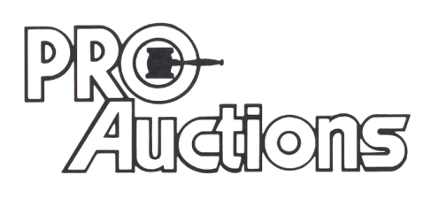

, LLC

[**www.auctionzip.com**](http://www.auctionzip.com)

**RICK GARNHART, AUCTIONEER**

**German Valley, IL 61039**

**815-238-3044**

**IL Lic: 440000901 WI Lic: 2844-52**