**FARMLAND AUCTION**

**161.87 Acres in Ogle County**

**Sat. April 6th at 10:00 AM**

**Live Auction held at Bertolet Building**

**103 W. 2nd St., Leaf River, IL**

**Total of 161.87 Acres MOL offered in 1 Tract. Currently 110 Acres in**

**row crop (119.5 PI) with good productivity. 34 Acres former old CRP/Hunting ground. 17.87 Acres building site, waterways, fence rows, road frontage.**

**SELLER: JAMES LEE STUKENBERG TRUST**

**LOCATION OF PROPERTY: 4207 TOWNLINE RD.**

**LEAF RIVER, IL 61047**

* **NW Soils: Osco, Rockton, HEL Ground**
* **Spring 2024 Possession**
* **Hard road frontage**

**Attorney for Estate: Laird Lambert**

**Note: This property is an unusual opportunity to add to your farming operation, as well as advance potential recreational opportunities. View maps, photos, videos, sale terms and other at auction website. Call Rick Garnhart, Auctioneer for complete information.** [**www.proauctionsllc.com**](http://www.proauctionsllc.com)

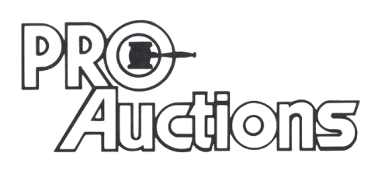

, LLC

**RICK GARNHART, AUCTIONEER**

**German Valley, IL 61039**

**815-238-3044**

**IL Lic: 440000901 WI Lic: 2844-52**