**LARGE FARM TOY AUCTION**

**SAT. FEB. 3 9:30 A.M.!**

**(Storm Date: Sun. Feb. 4)**

**Douglas Hildebrand Trust, 2ND AUCTION**

**Jane Addams Community Center**

**430 W. Washington St., Cedarville, IL 61013**

**600+ PCS HIGH QUALITY FARM TOYS!**

**RARE PEDAL TRACTORS: IHC (SH) Special Edition; IHC 826 Gold Demonstrator.**

**FARM TOYS, 90% NIB: Big Bud 370- 1/32nd; Big Bud 747-1/16th, NIB; 2- Big Bud 525-50-1/32nd; Toy Farmer Big Bud 16V-747-1/16th, NIB; Oliver 1950 w/ terra tires; Oliver 770, Iowa Pork; JD: Precision A, 4450, 4960, 4010, 12A Combine, 9300 4x4, 8870 4x4, 8410, 4955, 8760, 8560, 8200, 620 HC, TF 4230, 2-JD 6 B. Plows, Rare Precision 8020 4x4, 720, 820, 850 Dealer Promo, 4020 FFA; IHC: 1456, 1466, 756, 1566, 966, 806, WD-9, 340 Crawlers, 460-560 Set, 400 HC, 826 Rops, 806 w/ 3 pt, 1586, 1486, 1568, 1486, 1568 V-8 White Cab, 1568 V-8 Black Cab, 4 R. Corn Planter, 7120, 7140, Prec. IHC F-12, 600, 706, 1066, 5,000,000 IHC 1066, 4 R. Corn Planter, 826 Gold, 1456 Gold hood, 826 Gold hood, 1026 Gold hood, 7488 2+2, 3588 2+2, Red power 706, 80621206 Yellow D-RARE; IHC A,B,C Set NIB; 2 Custom 1206 NF IHC; CIH: 8950, STX 440, MX110, 5250, 5120, 5130, 3294 FWA, 4994, 245 Dealer; CASE: Case 1170 Black Knight; Case DC4; Case DC3; Case L; Case 600; Case 970 w/ Plow; Spirit of Case 2005, red, white & blue; TM Case 730; 10-1/16th Case Tractors; AC: 8010, 8030, 220, D-17, VAC, D-15, 2-AC D-21, Iowa FFA, 190 XT, 190 XT FFA; T.F. AC 270; Steiger Panther; Toy Farmer MF 44D; MX 285; WFE 2-180; Ford 8000; MMG 750 Rops; Joal NH TX 34 Combine; 300+ 1/64th Tractors & Implements; Rare Duralon 1/16th Semi Truck; 1/64th Semi Trucks; 20+ Joal Construction Toys; 25+ Muscle Cars; 30+ JD Collector Plates; Tin Signs; Plus much more to unpack yet!! *Note:* As in the 1st auction of this trust, all toys are excellent with most NIB. Hard to find this type of quality. Many to choose from. Don’t miss this exceptional opportunity.**

***Terms: Cash or check w/ picture ID required. Auction held inside with seating & restrooms.***

**Check website for many pictures. www.Proauctionsllc.com**

**RICK GARNHART, AUCTIONEER**

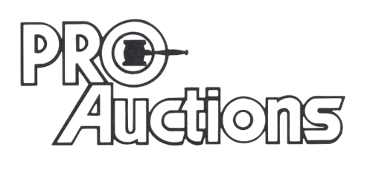

, LLC



, LLC

**German Valley, IL 61039**

**815-238-3044**

**IL Lic: 440000901 WI Lic: 2844-52**