**LARGE TOY AUCTION**

**SAT. DEC. 2 9:30 A.M.!**

**Rich “R.J.” Johnson Estate, Freeport, IL**

**AUCTION HELD AT: JANE ADDAMS COMMUNITY CENTER**

**430 W. Washington St., Cedarville, IL 61013**

**150+ CONSTRUCTION TOYS, NORSCOT, JOAL (95% NIB) 1/50, 1/32, 1/64: CAT: D10 Dozer, 140 Grader, 980G Loader, Skidder, 773 Truck, 825, Challenger, Combo, 5080 Shovel, 623, 345, Dealer Truck, 580, 725D, D350, 950, 12 Grader, 777 Truck, 360B, 534D, 308C, 992G, 24H, 980G Fire, 365B, 777D, D8R, 924G, 657G, 3380 Backhoe; 2 Volvo BM170; Volvo BM6300; Volvo FH16 Lowboy; Komatsu WA900; Komatsu Airport Grader; Komatsu HM400; Terex AC500 Crane; JD 850C; JD Fire Machine; JD 450LC; Case CX210 Exc; PPM 530 Terex Crane; IH TD-25 B Mack; IH 175 Loader; IH TD 24 Pipelayer. RARE 25+ BOXED PLASTIC MODEL KITS: AMT, ERTL, ETC. (NIB) OF TRUCKS & TRAILERS: Kenworth; Diamond Reo; Peterbilt; Logger Trailer; Lowboy; Wreckers; Cab-over; Mack; IHC Scout; White; Auto Car; Firetrucks; Cement Mixer; Cattle Haulers; Plus more. 25+ ASSORT. TRUCK & ANIMAL BOOKS: 1940 Fairy Tales; 1940 Children’s Books; Western’s; 1920 Hans Brinker; Many old School Books. TRUCKS-CARS-FARM TOYS-MISC: Assort. Farm Tractors; Old Farm Toys; Old Games w/ Boxes; Pin Ball Game; Mickey Mouse Train; Marx “Mortimer Snerd”; Tin Toys; Wood Barn w/ Animals; Marbles; C.I. Bank; Erector Set; Structo Jeep; Structo Car Semi w/ Trucks; Plastic Trucks & Cars; 1/64 Plastic Trucks & Cars; Old Coca Cola Trucks; Texaco Truck; 1/64 Nascar Big Rig Truck; Route 66 Trucks; Construction Semi Truck w/ lowboy; Mobil, Gulf Trucks; 30+ 1/64 Semi Trucks NIB; Kent Feed Truck; Mack Snow Plow Truck; 200+ Assort. Trucks NIB, all types & sizes; Wreckers; 1/64 Big Bud 16V-747; Big Roy. *Note: A very large, unique auction of Trucks, Construction and old memorabilia items. 35+ totes yet to unpack. Rich was an avid toy collector, and collected for 50+ years. Many items in orig. old boxes! Auction held inside w/ seating, Lunch, and restrooms. Terms: Cash or check with picture ID.***

**Check website for many pictures. www.Proauctionsllc.com**

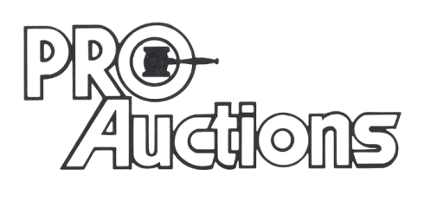

, LLC

**RICK GARNHART, AUCTIONEER**

**German Valley, IL 61039**

**815-238-3044**

**IL Lic: 440000901 WI Lic: 2844-52**