**LARGE FARM TOY AUCTION**

**600+ PCS.**

**SAT. SEPT. 23 9:30 A.M.**

**JANE ADDAMS COMMUNITY CENTER**

**430 Washington St., Cedarville, IL 61013**

**JOHN MAVEUS COLLECTION – MONROE, WI: Precision IHC SM; CIH Magnum Series 7120, 7140, etc; CIH S7X 480-Duals; CIH 7250 Anniversary; IHC L&G: 125 & cart, 1250, 147, 682; IH 1466, 966, 856; IHC 460, 560 2 pt & F.H.,404, 340 ind; Rare AC 190 NIB; JD Argentina 4020; 2 IHC 560 Pullers; Milwaukee Plastic M & Wagon; 1987 Erytl Carpenters Set w/ Saw & Hat, NIB; JD 4020, 3 Versions; JD 6020 Custom; 3 Oliver 1850; Oliver 950; 2 JD 630 w Plows; JD 60 w/ mtd. Picker; JD: 14T Baler, 4 B. Plow, 494 Planter; TS: 560, Picker, Drill, 3 Carts, 2 4-B Plows, 2 pull Combines; 2 Elevators, Baler; 2 AC Plastic Prod Miniature Tractors; AC 7050, 7040 maroon; 2 AC C Tractors C.A.; Reul Barge Box; Rare Smith Miller Log Hauler w/ Pup Trailer; Assort. Tonka, Structo, Nylint Trucks; 1952 AC Tractor Calendars, Freeport, IL; 2-1959 AC Banners; Buddy L Sunshine Biscuit Truck; 1950’s Marx Train Set NIB; Plus other 1/64th & many other high quality Toys. FRED WAGNER ESTATE – CEDARVILLE, IL: 1980-1990 New Lego Box; Kamerude Books & Prints; JD: A, B, G, 420 NIB, 630, 620, 70, 4020, 7800; Farmall 806, 350, 1456, 1566, 1586, 100 hydro; Lg. Bank Collection; Iowa FFA; IHC: Cub, F-20, 200, A; Farm Progress Tractors; Structo Car Hauler; AC D-17; Lafayette 10+ Show Tractors; Precision IHC Little Genius Plow; Precision A; Precision F-20; NFTM JD 502C; Model Car-1/16th & 1/64th; JD 2755 Ind. Toys; Joal Ind Toys; Mask/Kenner w/ Box; JD 6000-7000 Tech Series; Midget Dirt Cars.**

**LLOYD HOSHAU ESTATE – BYRON, IL: JD Model G w/ Plow; Oliver & JD Signs; MM TSC Tractor, MM 750; JD 3020; JD Crawler; Case L; JD Waterloo Boy; Oil-Pull; MH 101, 22; JD Grain Drill; AC Roto Baler; Rare Custom Made IH C Corn Binder; Tonka Trucks; Case DC; MF, Gray; Precision AC WC, steel #1; Precision Ford 9N; MM UB NIB; Oliver 770 NIB; Plus many more to unpack.**

***Note: A very large auction of high quality. Be sure to look at all pictures on web site. Auction held inside w/ seating, Lunch, and restrooms. Terms: Cash or check with picture ID.***

**Check website for many pictures. www.Proauctionsllc.com**

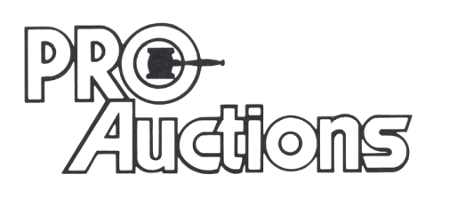

, LLC

**RICK GARNHART, AUCTIONEER**

**German Valley, IL 61039**

**815-238-3044**

**IL Lic: 440000901 WI Lic: 2844-52**