**MASSEY FERGUSON TOY & COLLECTIBLE AUCTION**

**SAT. JULY 15 9:30 A.M!**

**Jim Schlappi, Browntown,WI**

***Auction held at: Jane Addams Community Center,***

***430 W. Washington St., Cedarville, IL 61013***

**2nd in series of Auctions for this Collector (80%) NIB TOYS: 1/16 Combine Series: 760 Gray & Yellow wheels, 9790, 8780, 850; Rare Massey Ferguson 2805 “Warpath Puller”; Massey Ferguson Hood Ornaments; New Massey Ferguson Cab & Tractor Motorola Radio; Massey Ferguson Planter Tester Unit; 25+ Tractor Books; Some Massey Harris Toys; Assort. Tin Signs; Lg. Amt. Massey Ferguson – Massey -Harris Coats, Shirts & Hats; Rare Cast Iron Massey Harris Seat; Assort. Massey Harris Tin Seats; Ski-Whiz Snowmobile Adv; Other Literature Snowmobile Literature; 50+ Rare MH-MF Belt Buckles; American & Canadian; Lg. amt. Pens & Pencils; Massey Ferguson-Massey Harrison Patches; Massey Ferguson-Massey Harris Literature; Rare European Massey Ferguson Literature; Lg. Assort. New-old stock oil, grease filters NIB; 10+ 1980 Tractor Banners; Ski-Whiz Banner; Massey Ferguson 8650 Pedal Tractor; Massey Harris Parts Boxes; Dodge Bros. Radiator for Dodge & Pontiac Car parts; Massey Ferguson Micro-Fich Machine w/ tower & 100+ cards; Marbles; Paper Plates; Vintage Filters; Banners; Cups & Plates; Wrenches; Key Chains; Rare 4 Boxes Massey Ferguson Spark Plugs; Xmas Ornaments; 1/64 Semi Trucks; 50+ 1/64 Massey Ferguson Tractors & Combines; Match Books; Massey Ferguson Wallets; Massey Ferguson End wheel Grain Drill; Lots Early Massey Harris & Massey Ferguson sales Literature; 25+ pcs. Massey Ferguson Ind. Literature; Orig. Ind. Binder; Plus much more. *Note: Fantastic collection of rare Massey Ferguson items. Many items not listed*!**

***Terms: Cash or check w/ picture ID. Seating, lunch stand & restrooms available***

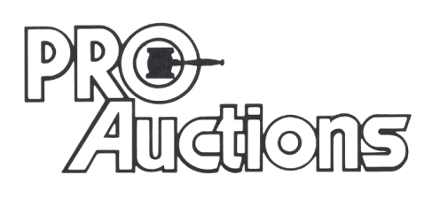

, LLC

**Check website for MANY GREAT PICTURES!!**

**www.proauctionsllc.com**

**RICK GARNHART, AUCTIONEER**

**IL Lic: 440000901 WI Lic: 2844-52**

**German Valley, IL 815-238-3044 **