HUGE FARM TOY AUCTION
600+ PIECES COLLECTION
SAT. JUNE 24 9:30 A.M.
Dan Nelson – Polo, IL
Sale held at: Jane Addams Community Center
430 W. Washington St., Cedarville, IL
75% NIB FARM TOYS: Precision JD: 9750 ST Combine, 3010 Tractor, 70 Tractor; Prestige JD 45 Combine; JD: 4520 200th Birthday, 4010 HiCrop, 70 HiCrop, 40-70 Set, 4040, 6600 Combine, metal Reel, 520/620 Set, MI, 40, 9420T, 60 w/ Picker Sheller, 8300, 9600 Combine; IH: 656 Gold Demo, Precision 400, 600, 460 Restoration Set, Hydro 100, S-AV, 2-2+2 7488, 1456, 5088, 7250, Cub w/ blade, 350 High Crop, 6388 2+2, 2-1486; CIH: S-AV, 7250 MFD, 5488 AWD, 706 w/ plow, 2-2+2 7488, STX 450; Case 2595, 2390, 2596730 w/ wagon; MF 878 Combine; Belt Buckle Collection; Watch Fob Collection; 6 Remington Game Bird Trucks Sets; 25+ 1/64 Semi-Truck Trailers; Assort. JD & Case Truck Banks; 30+ Pcs. Tru-Scale Implements; Tonka; Farm Related Memorabilia; 20+ Numerous flats 1/64, 1/32 Tractors & Implements.
Note: Large selection of IHC & JD Toys. This is 3rd auction for this Collection. 200+ not listed
Farm Toys to be unpacked.
Terms: Cash or check w/ picture ID. Seating, lunch stand & restrooms available

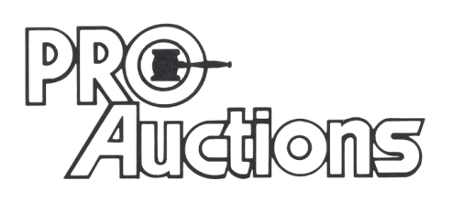
, LLC
Check website for MANY GREAT PICTURES!!
www.proauctionsllc.com
RICK GARNHART, AUCTIONEER
IL Lic: 440000901 WI Lic: 2844-52
German Valley, IL 815-238-3044

