LARGE FARMEQUIPMENT
AUCTION
SAT. JUNE 10 10:00 A.M.!
Randy & Jodi Manus
7711 E. Kelly Rd., Ridott, IL (815-990-0266)
LATE MODEL FARM EQUIPMENT (Washed & waxed, superb!)
1993 J.D. 9500 Combine, Chopper, 3806 hrs, 2777 Separator, 2nd owner, newer rubber!; 2002 J.D.
693 Corn Head, knife rolls, hyd deck plate, 1 owner; 2001 J.D. 920F-20’ Grain Head, 1 owner; 2019 Unverferth 25 HT Head Cart; 1993 J.D. 7800 MFWD Tractor w/ P. shift, 7386 hrs, duals, new front tires, sharp!; 1980 J.D. J.D. 4440 Tractor w/ CAH, quad trans, duals, 5805 hrs, nice!; Westendorf WL-42 quit attach Loader, fits J.D. 30-60 series; Farmall 560 Gas NF Tractor, standard drawbar, new paint, newer tires, very sharp!; 1944 J.D. D.Tractor w/ wheel wts, all orig. cond, runs well; 2003 I.H. 8100 Semi Tractor, single axle, CAT engine, 10 speed, clean!; 1986 Jet Grain Tractor, 700 bu, LED lights, tarp; J.M. 750-16 Grain Cart w/ floater tires, tarp, scale, camera, small 1000 PTO!; 2012 J.D. 625I Gator, 4x4, PS, 590 hrs; Like new Unverferth 530 Gravity Wagon, 16 ply tires; 1988 CIH 496-22’ Disc, bought new!; New Pepin 24’ hyd. Fold Drag Cart Harrow; Glencoe 9 shank Soil Saver w/ leveler Bar; J.D. 7000-12N Wing fold Planter w/ J.D. 200 monitor, sharp!; J.D. F950-12’ Cultimulcher; J.D. 400 Rotary Hoe; Noble 6RN 3 pt. Cultivator; M.M. 5-16 Semi mt. Plow; Allied & Kewanee Augers; Woods 84-3 pt. Rotary Mower; Woods 315 Batwing Mower, 540 PTO; 2006 Mustang 25’ Flatbed Gooseneck Trailer; Winpower 20-12 PT2 Alternator on Cart w/ 540 PTO; 100 gal. Pasture Sprayer w/ 20’ Boom & hand gun!; 3 pt. Loader Bale Spear!; Farmall 3-16 Hyd. Pull Plow, new paint; Farmall 2-16 Trip/Steel wheel Plow, new paint; 200 bu. Parker Gravity Wagon on Doudan Gear; 2001 Yamaha Grizzly 4 Wheeler, 4000 miles, well maintained; HD Kerosene Hot Water Pressure Washer; Misc. 7000 Planter Parts;
2 Hayracks full of Misc. items incl. Chain Saws, nuts & bolts, Tools, etc; 5 hp Mini Bike, like new;
3 Surge Milker Buckets; 3 Galvanized 10 Hole Chicken Nests; 2-150 bu. Gravity Boxes w/ 6T. Gears, good cond; 3 pt. 8’ Woods Blade, Model #HBL96-2, like new; 3 pt. J.D. Quick hitch, fits J.D.4455, good cond; J.D. Hay Rack 8’, 5 bar; Dolly Wheel. Note: Exceptional line of well maintained, CLEAN EQUIPMENT!
Terms: Cash or check with picture ID. Letter credit from bank for big items.. Lunch Stand: Lunch Box

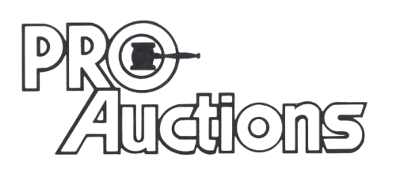Check website for EXCEPTIONAL pictures.
, LLC
www.Proauctionsllc.com
RICK GARNHART, AUCTIONEER
IL Lic: 440000901 WI Lic: 2844-52
German Valley, IL 815-238-3044

