LARGE TOY AUCTION
SAT. APRIL 15 9:30 A.M.
Ken Lego, Mt. Carroll, IL
Auction held at: JANE ADDAMS COMMUNITY CENTER
430 W. Washington St., Cedarville, IL 61013
OLIVER- M.M.-WHITE TOYS: OLIVER: 770, 77, 550, 1555 w/ rops, 1655, 20, 40, Slik 70 nf, Slik 70 wf, 80, 1955, Hart Parr 70, Hart Parr 28-44, Hart Parr 22-45, 70 steel, 90 steel, 80 steel, Spirit of Oliver, Hart Parr 70-Montana, 1/25th 1855-red, 1/25th 1855-green, 880 Ind.,
77 Precision, 1655 Sugar Valley, 1655 FWA, 1555 nf, 1555 NFTM, Custom 1855 w/ sprayer tanks, Wheatly S55, Wheatly 550, Wheatly 880, Super 77 Ind., 88-single front wheel, 440, 550 Ind., 550 Crossroads, WHITE: American 60 green & yellow, American 60 silver w/ Barn Set,
2-135, 6195. M.M.: Blackhawk 35, G550-Sugar Valley, G750, Comfort UDLX, 2-TC 17-28, U,
UTS, J. Lg. Assort. Of Oliver Implements. SPECIAL: 1/8TH Oliver 1850; 1/8th Oliver Flare Wagon; 1/16 Hart-Parr 30-60; Assort. Oliver Literature & Memorabilia; Oliver Safari Hat; Ash Trays; Hartman Stationary; 1938 Colehour Calendar; Oliver Manuals; Plus more Oliver Items.
OTHER, INCL. STRUCTO: 30+ Assort. JD, IHC, MF, AC, Ford Case Tractors & Implements; IHC Grinder Mixer; Hesston 4755 Big Square; TS Elevator; TS Plow; Coop #3, E4; Hesston 4755-Big Square; BF Avery; Structo: 10+ Trucks, Crane, Cement Mixer, Dozer, Jeep, Car Hauler; 10+ Tonka, Buddy L; Nylint.
AGRICULTURE & MISC. SIGNS: (all in excellent cond) Pride Seed; Royal Seed; Hulting Seed; Hubbard Feed; Fasco Feed; Columbian Feed; Mobil Oil; Clinton Engines; Stewart; Renk; Big H Safari Hat; Wells Fargo.
SOUTHWEST WISCONSIN COLLECTION: Pedal Tractors: JD 3010 3 hole, JD 4020
4 hole, JD 9870 Combine, JD A –Box, Early JD Metal Trailer w/ fenders; John Deere: 9300T, 7400 Harvestor, 24T Baler, 4010 High Crop, 1010 Crawler, 2-Gold Race Cars #97, HO Train Set, Lindaman Crawler, 12A Combine, 5 pc. Dealer Set 1/64, Early Eska JDA, Titan II Combine, 230 Disk, Historian Farm Set. NOTE: Extremely lg. Auction of Oliver items. Plus 75 other Tractors & Implements. High quality & rare Pedal Tractors & Combine. Very abbreviated list. Lots more to unpack.
Auction held inside w/ seating, Lunch available
Terms: Cash or check w/ picture ID. Preview 1 hr. prior to sale.
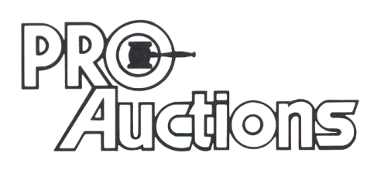
, LLC
Check website for many pictures.
www.Proauctionsllc.com
RICK GARNHART, AUCTIONEER
IL Lic: 440000901 WI Lic: 2844-52
German Valley, IL 815-238-3044

