**LARGE TOY AUCTION**

**FARM -CONSTRUCTION-DOLLS**

**SAT. APRIL 29 9:30 A.M.**

**AUCTION HELD AT: JANE ADDAMS COMMUNITY CENTER**

**430 W. Washington St., Cedarville, IL 61013**

**JIM BECKER FARM TOY COLLECTION-MONROE, WI-100+ Tractors, 90% NIB:**

**IHC: Spreader, 4 B. Plow, Baler, 3 Precision F-20- 2 Little Genius Plows, AV, Cub, 2-7488 2+2, 1086 Radio Control, 3588 2+2, 2-1568 v-8, 606, WD9, 1586 old box w/duals. CIH: 5140, 5250, 4994, 7240, 7140, 2594, Farm Set w/ box 4 pcs, 2188 Combine. J.D.: 4655, 6400, 4800, 8760 4X4, 7800, 9600 Combine, 6 B. Plow, Precision A-steel, Precision 4000, Radio Control Tractor, Precision JD 5 B. Plow, Precision JD-A, 7600, 2755, 8400, 8760 4wd, 2 Chuck Wagons,**

**JD D-100 yrs, Combine Turbo. PLUS Case; Cockshutt; Oliver; AC; Hesston; MM; etc.**

**SPECIAL ITEM: 1930’S Keystone Fire Truck w/ 3 ext. ladders, all original!**

**RAY McMAN COLLECTION, BELOIT, WI-75+ CONSTRUCTION TOYS & TRUCKS:**

**1/64, 1/50, 1/32 SCALE, HIGH DETAIL. J.D.: 850, 200, S44, 310, 850C. CASE: 621B, 9030, 650W, 590S; N.H. DC 180B; JCB Loader. IHC: Freightliner Peterbilt, Mack. CAT: C5, D250, 988G, 924G, 140H, 247, 988B, 611, Dion, 953B; Liebherr Dozer Loader; Samsung Loader; Plus more Construction. OTHER CONSIGNMENTS: RAILROAD TRAINS & MEMORABILIA: Union Pacific RR Coats, N.W. RR; Lionel Train Set; HO Engines & Cars; 20+ Lionel Buildings; Other HO Train Items; Plus numerous train memorabilia; 6 wall mt. Display Cases w/ glass front for Engines & Cars. MISC: Cars & Trucks incl. Racing Champions; Harley Davidson; First Gear; Match Box; Bobble Head Collection; 1960 Hot Rod Magazines; Old Comic Books;**

**4 tables full of Green County Advertising & Collectibles from this area incl. Auto, Farm, Business. DOLL COLLECTION:**

**50+ NIB: Raymond George; My Way Babies; Babies-a-Bloom; Baby Peg; Dellafield Doll; Paradise Galleries; Pauline LE; Charismin; Elite Dolls; Black Dolls. *NOTE: Large collections of a variety of toys and huge amt. of advertising and collectibles. You certainly don’t want to miss this one!!***

***Auction held inside w/ seating, Lunch, and restrooms***

**Check website for many pictures. www.Proauctionsllc.com**

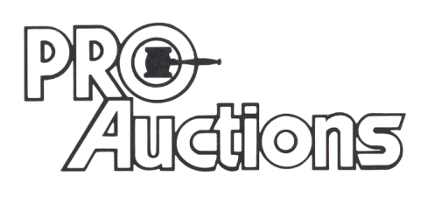

, LLC

**RICK GARNHART, AUCTIONEER**

**German Valley, IL 61039**

**815-238-3044**

**IL Lic: 440000901 WI Lic: 2844-52**