FARMLAND REAL ESTATE AUCTION
THURS. MARCH 23 10:00 A.M.
74.82 ACRES M.O.L.- OGLE COUNTY, IL
“ZUMDAHL FARM”
Property Location: Corner of Montague Rd. and S. Bunker Hill Rd, south of
German Valley, IL (Ogle-Stephenson County line)
- Legal Description: T25N.-R.8-9E. Section 6, Maryland Township
- Highly productive, well drained. Soil types: 86B, 86C2, 3074A, 3451A, 86A
- P.I. 135.6
- Nearly 100% tillable one big field.
- Hard Road frontage!
- 2023 Spring Possession

Auction held at: German Valley Fire Station, German Valley, IL
Attorney Dave Shockey, Freeport, IL 815-235-2507
Call Auctioneer for additional information.
Terms, Maps and Pictures on website: proauctionsllc.com
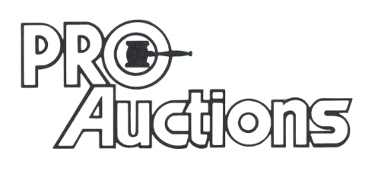
, LLC
RICK GARNHART, AUCTIONEER
IL Lic: 440000901 WI Lic: 2844-52
German Valley, IL 815-238-3044

