HUGE FARM TOY & MEMORABILIA
TOY AUCTION
SAT. FEB. 25 9:30 A.M.!
Jim Schlappi Collection, Brown Town, WI
1st of 3 Auctions of M.F. & M.H. Collections
AUCTION HELD AT: JANE ADDAMS COMMUNITY CENTER
430 W. WASHINGTON, CEDARVILLE, IL
35+ YR. COLLECTION-MF & MH, 70% NIB: 175, 2805, 555, 2680, 1080, 50, 55, 135, King 44 w/ spreader, 50E, 2775, 699, 2-760 Combines, 98 GM Firestone, 1433, 1155, Iowa FFA 1150, Ind. Tractor/Rops, MF 1800 4x4, 640 Planter, 98 w/ loader, 3660, TF 1155 Spirit, MF 1150 w/ Rops, 398, 165 w/ wts, MF 670, Rare Gold Ski-Whiz 400-1 of 100, Red Ski-Whiz 400,MF 1100 wf, MF 2925 L&G, 333, 275-Rops, Rare pewter 3070, Agricola 1014, Prazscions 2640, MF Bank Collection, 1/64th Semi Collection, T5 Yellow Wheel Combine, MF 590, Rare MF 860 Gray Combine. MF-MH SPECIAL ITEMS: Adver. Items, all types; Yard Sticks; MF Radio; MF Puzzle in can; Owner &Operators 1930-1950; L&G Literature; MH Buyers Guides; Calendars; 20+ MH Filter Boxes; MF Oil Bottles; New MF Spark Plugs w/ case; Rare 20+ Assort. MF-MH Parts Boxes; Orig. Sales Receipts MF-MH; Plus more numerous adv. Items.
MIKE MCNAMES ESTATE, formerly from Freeport, IL: 50+ IH TOYS, ALL NIB:
IH: 340 Crawler, T-14 Crawler, Little Genius Plow, Lafayette 300+ 2 R. Planter, Cub w/ Plow, 350 Demonstrator w/ brass Tank, 766 Forreston FFA, H w/ Planter, 450 HC, 47 White Baler, 300-400 Set, 400-w/ 3 rear Mower, Millenium JD Frolich Tractor; Rare Freeport Show Oliver S-88, Forreston S-77 Green wheels, 706 Signed, TD 14 Crawler, SM w/ mtd.2 MH Picker, Restoration M, #82 Pull Combine, Set ABC Tractors, 450 w/ mt. Disk, 350 w/ 255 Cultivator, Cub w/ Planter, Cub w/ yellow Snow Blade & Chains, Cub Lo-Boy, Yellow Ind. 340 Tractor, WI Tech Green Co. IH 340 w/ Planter, IH Cub w/ 1 R. Planter, Misc. IHC Hats & Gloves, etc.
Terms: Cash or check w/ picture ID. Seating, lunch stand & restrooms available.
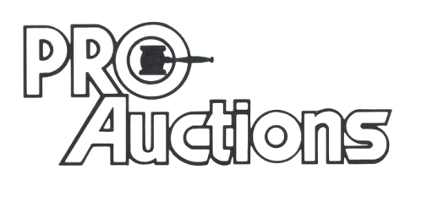
, LLC
Check website for MANY GREAT PICTURES!!
www.proauctionsllc.com
RICK GARNHART, AUCTIONEER
IL Lic: 440000901 WI Lic: 2844-52
German Valley, IL 815-238-3044

