HUGE 600+ FARM TOY AUCTION
SAT. MARCH 18 9:30 A.M.
BRETT HOLADAY ESTATE, FORRESTON, IL
JANE ADDAMS COMMUNITY CENTER
430 Washington St., Cedarville, IL 61013
1/16-1/32-1/64 FARM TOYS & SEMI TRUCKS (90% NIB):
1/8 JD 6500 Sprayer; Ford 8970, 8770; AC 7080, 50 yr; Case 1170 Black Knight; MM G940;
JD 4010; Agri King 1170; CIH 5250 MFD; 2 AC 220; MH 1100; IHC 4366, 660; National Farm Toy Show Tractors: AC D-19, MF 1500, Case 2470, MF 444, JD 7020, AC 7580; Sugar Valley 1655 Cockshutt; Toy Farmer 1155 Spirit; MM-UTE, 4 star; Precision IH Regular; 1/32 Claus Chopper w/ cart; Rite 750; AC 8010, 7060, 7010, 8030; 9 IHC 1/64th Historical Sets; Oliver 770, 880 single, 880 WF, 80 WF, S66, 70, etc; Oliver Cletrac HG; Big Bud 1/64th NIB:310, 370, 440, 500; JD 8870, 4x4; MF 1150 NF Show Tractor; Many Toy Farmer Tractors; 1/32 MF 1500, Case 2470, Oliver 2655, IH 4366, AC 7580, IHC 2+2, Oliver 1950T, JD 7020, Steiger Tiger 525, Steiger Panther 325; 1/64th Farm Sets NIB; AC 220-ROPS, D-19 w/ loader; Structo Trucks; 35+ 1/64th Semi Trucks, NIB; 1/64thFirst Gear Construction Semis; JD 2520 NF, B; F.P. AC 190; NI Anniversary Spreader; IH 1568, V-8; CIH 7120 FWA; White 2-135 Gray & Red Stripe; Tractor Literature; 100+ Old Toy Farmer Magazines; 250+ 1/64th Tractors, Combines, Implements, Oliver, Ford, JD, MF, Steiger, etc; Custom 1/64th Show Cases, wall mount; Plus much more high quality farm toys in this collection. SPECIAL: J.D. 4020 Pedal Tractor w/ cast seat.
Note: Large sale of high quality Toys, many NIB Items.
Auction held inside w/ seating, Lunch, and restrooms

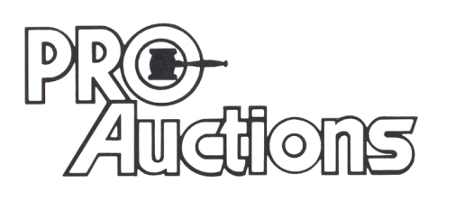 Check website for many pictures. www.Proauctionsllc.com
, LLC

RICK GARNHART, AUCTIONEER
German Valley, IL 61039
815-238-3044
IL Lic: 440000901 WI Lic: 2844-52

