HOUSEHOLD & ANTIQUE AUCTION
SAT. JULY 8 10 A.M.!
(RAIN DATE: SUN. JULY 9)
JERRY LUDEWIG COLLECTION
8369 N. FORK CREEK RD., FORRESTON, IL (815-821-1288)
ANTIQUES-HOUSEHOLD-QUILTING ITEMS: 100 Yr. old Oak Curio Cupboard; Purchased at Goods, Kewanee, IL: Round Oak Table w/ lg. leaf & 4 chairs, Oak Side-by-Side Secretary, Fancy Oak Bedroom Set incl. Post Bed, Gentlemen’s Dresser, Ladies Dresser & Mirror, 2 night stands; Monticello 6’ Grandfathers Clock; 5 Quilt Sewing Machines; 3 Quilt Tables; 20+ Lg. & Sm. Quilting Racks; Quilt Supplies; Boxes of Fancy Work incl. Doilies, etc; 50+ Picture Frames; 100 yr. old drop Leaf Table; 500+ Salt & Pepper Shakers; Hand made Rugs; 40+ Longaberger Baskets; Wicker Rocker Chair; Oak Arm Rocker; Assort. Pine & Oak Chairs; Boxes of Craft & Stamping Items; 2 Elec. Pottery Kilns; Card Making Supplies; Carnival Glass; Homemade Jewelry Boxes; 10 Assort. Crocks & Jugs; 2 Accordians; Oak Bed; Carved Oak Lamp Table; High Chairs; Bunk Bed, made in Woodbine, IL; 25 hand painted Bird Houses; Yard Stick Collection; Marbles; Pens; Pencils; Some Local Adv. Items; Wagon full Glass & Dinnerware; Elec. Wheelchair; Pepsi Pop Crate; Pots & Pans; Tea Sets; Precious Moments; Alewine Pottery; Thirty One Bags; Isabell Blooms Pottery; Disney 8 track tapes; Bradford Exchange plates; Lots yard deco; Golf Clubs; Plus much more. SPECIAL: New York Yankees Babe Ruth and Lou Gehrig framed picture. Also 1932 New York Yankees Team picture w/ Babe Ruth.
Note: Everything very clean; lots of unique items. 4-5 wagons full. Terms: Cash or check w/ picture ID. Lunch Stand on grounds.

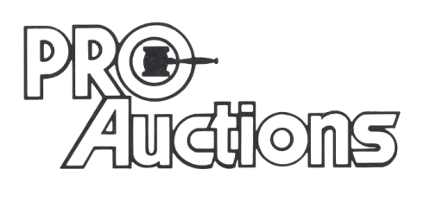Check website for many pictures.
, LLC
www.Proauctionsllc.com
RICK GARNHART, AUCTIONEER
IL Lic: 440000901 WI Lic: 2844-52
German Valley, IL 815-238-3044

