HUGE FARM TOY AUCTION
SAT. FEB. 11 9:30 A.M.!
(STORM DATE: SUN. FEB. 12)
JANE ADDAMS COMMUNITY CENTER
430 Washington St., Cedarville, IL 61013
DAN NELSON COLLECTION – POLO, IL
600+ TOYS:
SPECIAL ITEMS: Farmall Super M Pedal Tractor; IH Red Power 10’ Banner featuring 5088 Tractor; Ford 1/8th Tractor & Wagon.
JD: 9300T 4x4, 5020, 4850 FWA, 8650, 5010, 8400, 4955, 70 Precision, 730, 720 HC, B w/ umbrella, 12 Combine, JD GP, 8760 4x4, 9610 Combine, 4010, 630 LP, 4020 w/ 3 pt, 8020, 4450, 4020 w/ duals, 50-520 Set, 2640 FD, LA w/ Mower, Plus 30+ JD Implements & assort.
JD Toys. IHC: 1566, 1256, SH, IH Max 5,000,000, 856, IH Mag, 460 Orchard, 1086, 1468, 1066
Special Ed, 826 Rops, 1586, 544, 504, T340 Crawler, 2-3588, 2+2, 460 Precision, 520 Precision, 1456, 886, 1456 Gold, 5288, 4994, Plus other Assort. IHC Implements. OTHER: Ford 9N 50th Anniv; 25+ Assort. Pickup Truck Banks; Danbury Mint Plates; Boone County Fair Buggy;
Oliver 88; 6 Pc. Hubley-MH; Oliver S-77 Puller, Louisville; MF; Fox Fire; New Holland TR Combine; True Scale; JD Pocket Knives; MF 8680 Combine; CIH Historical Sets; Airplane Banks; Assort. Belt Buckles; Ford Big Blue; 6 Pace Setter Decanters w/ boxes; Assort. Cars.
1/64th: IHC 66 Series, 9 boxes full set; IHC White 5,000,000; IHC Collectors 100-200-300-400; JD Historical Sets; Woods Semi; CIH Steiger Cougar II; AC Lawn & Garden Set; CIH Belt Harvestor; Gleaner; MF; Case 1370; CAT; Plus Other Tractors.
Auction held inside w/ seating, Lunch available
Terms: Cash or check w/ picture ID. Preview 1 hr. prior to sale.
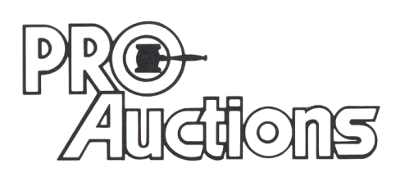
, LLC
Check website for many pictures.
www.Proauctionsllc.com
RICK GARNHART, AUCTIONEER
IL Lic: 440000901 WI Lic: 2844-52
German Valley, IL 815-238-3044

