HUGE FARM TOY AUCTION
SAT. OCT. 15 9:30 A.M.!
DAN NELSON, POLO, IL
Sale held at: Jane Addams Community Center
430 W. Washington St, Cedarville, IL
ALL MAJOR BRAND FARM TOYS, 1/16TH, 1/32ND, 1/64TH, 90% NIB: Rare Degelman Rock Picker; 1970 Early Case Farm Set w/ 930, Barge Box, Spreader & Plow; Kinzie Planter; 2 Big Roy 1080 Toy Farmer; IHC 47 Resin Baler; Farmall M 1/8th F.P.S. Indiana; T.S.: Combine, Elevator, Mower, Combine, Wagon; Hubley Tractors; Key Series JD 1/16; Precision JD A, A& Cultivator, 70, 4020 w/ 237; Precision 4020 NF; MF 1100 NF & WF; 2 Precision F-20; IHC 2+2 White Cab; 500+ Pcs. 1/64 NIB-IH, Case, CAT, NH; JD SN mt. Picker; IHC 544 Red & Yellow; JD 40 Crawler; JD: 5010, 5020, 830, 60, 1010, 4010, 60 WF, 4230, 7800, 2640, 566 R. Baler, A plus others; Precision Oliver 77; IHC: Cub w/ Planter, W400, 1566, Hydro 100, 856, 1066, 966, 1206, 230, 544, 5088, 660 ID; Case-IHC: 30, 7150, 7140, 370 CWT, 7230 Anniv; JD -6 4x4 1/16th; Case –IHC: 3288 Prestige, 3294, B Blue Ribbon, 7250, 1566 Prestige; 535 Quad Trax Denver Ed, STX 500 4x4, 9150, 4586, 4994 4x4, 8800 Sugar Cane, Manure Spreader; NH Forage Wagon; Tonka Crane; Tonka Grader w/ Plow; Steiger: Cougar 1000, 3 pt, Bearcat Series 1; Super Wildcat 4x4; Assort. 1/32nd Vintage Tractors & Implements; JD: 6 B. Plow, 4 B Plow, Haybine, MT, Assort. Skidloaders Round Balers, Remote control Tractor, etc;
SPECIAL: ARCADE TRUCKS & CARS: (be sure to see pictures on website) Blue Stake Truck; Red Fuel Truck; 3 Buses; Assort. Cars; Red Delivery Truck; Road Signs.
FARM LITERATURE: 10+ Boxes Ag & Trucks. Note: Much more, many boxes to unpack. This is the first of three Auctions for Dan Nelson Collection! Watch for later auction dates.
Seating, lunch stand & restrooms available.
Terms: Cash or check w/ picture ID.

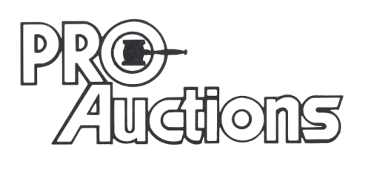
, LLC
Check website for MANY GREAT PICTURES!!
www.proauctionsllc.com
RICK GARNHART, AUCTIONEER
IL Lic: 440000901 WI Lic: 2844-52
German Valley, IL 815-238-3044

