600+ HUGE FARM TOY AUCTION
SAT. SEPT. 10 9:30 A.M.
JEFF MAYER COLLECTION – WINSLOW, IL
AUCTION HELD AT: JANE ADDAMS COMMUNITY CENTER
430 WASHINGTON ST., CEDARVILLE, IL 61013
500+ 1/64TH TRACTORS & IMPLEMENTS, NIB (1980-2010): Custom Show Tractors-show Editions; 20 Farm Sets from 1980; 4x4 Tractors-JD, IHC, White; 2 rare MF 2800,
2 versions; Rare Ford 9700; Hesston Tractors; 2 Big Bud 525-84, 2 versions; CIH; IH; Fiat; Case; European JD; Combine Collection; Planters; JD, Oliver, IHC Historical Sets; NH; Steiger, all colors; Chrome JD Sets; 4’ Timex 1/64th Show Case; Plus much more 1/64th.
TRACTORS – 1/16TH, 1/43RD, 1/8TH – TRUCKS – SIGNS: Albany, WI: Kasture JD 4010, 70, 80, 3010, 6400, 7800, 45 Combine; 11 Big Bud, 1/43rd all versions, Valley Cast, Rockford, IL incl. 16V-747; 1/8th JD Model L Manure Spreader, Model B Tractor, Flare Box & Gear;
JD 50-60; JD 40-70 Sets; Case TTT Spirit 76 (Red White & Blue); 35 State JD Tractors; Premier JD Tractors w/ coin; National Museum Sets; White American Set w/ box; JD 8760 4x4; CIH 7120, 7140; NH Grinder; AC Special Roto Baler; Case 1030, orig; T.S. Combine & Elevator; Yellow Steiger Ind. 4x4; CIH, AC, MF, Versatile 1/43rd; AC L&G Set; White American Series “60”; DA 9150; MF 44, 3070; JD Nascar; 1/64 Semi Truck Collection; 25 Nylint Trucks & Toys; Structo Trucks; Tonka Truck; 3 Tin & Wood Barns; 4 RR Cast iron wheels & frame for cart;
20+ Assort. Tin Signs: Pioneer, Moews, DeLaval, Milk Keeper, plus more to be unpacked!
Note: Extra large Auction of 1/64th and others. Many rare special Tractors NIB of high quality! Need to attend!
Terms: Cash or check w/ picture ID. Seating, lunch stand & restrooms available.

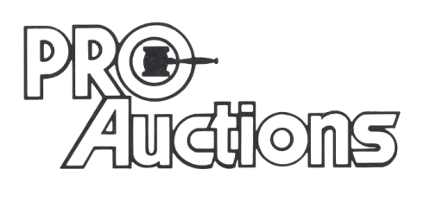
, LLC

Check website for MANY GREAT PICTURES!!
www.proauctionsllc.com
RICK GARNHART, AUCTIONEER
IL Lic: 440000901 WI Lic: 2844-52
German Valley, IL 815-238-3044

