TOY TRAIN-LITERATURE-ANTIQUE FURNITURE
AUCTION
SAT. AUG. 13 9:30 A.M.
JIM FULTON ESTATE – LENA, IL
AUCTION HELD AT: JANE ADDAMS COMMUNITY CENTER
430 Washington St., Cedarville, IL 61013
TOY TRAINS & R.R. MEMORABILIA: 6 HO J.D. New Train Sets; Alco Baldwin BP-20 Brass Engine; Athearn & Atlas Unpainted Cars; N.& HO Cars & Engines; HO train Shells; McKearn Model R.R. Building Kits; Layout Building & Scenery; R.R. Engine & Car Parts; R.R. Red Signal Light (ICRR); Train T-Shirts & Aprons; Train Photos; R.R. Literature-Time Tables, etc; R.R. Plates, Mugs, Pencils; Adlake R.R. Lanterns; VHS R.R. Movies; 25+ Train Books; R.R. Coal Bucket, etc; Train Schematics; R.R. Clocks; Air Brush Equipment for painting trains. MISC. ITEMS: State Police & Misc. Posters; Egg Scale; Coca-Cola Items; Wood Pop Case; Western Magazines; 25+ new Parker Pen Sets; Pocket Knives; Cub’s Baseball Items; Military & Silverware; Xmas items-Angel Collection, Old Ornaments plus much more; 600+ Coffee Cups incl. Advertising, Norman Rockwell, Thomas Kinkade, plus much more; Hat Collection; 20 Boxes Misc. Glassware; Fruit Jars. ANTIQUE FURNITURE (All extra Clean): Oak Commode; Oak T Bar Wash Stand; 1900’s Pine Cupboard; Harvest Table; Carved Rocking Chair; 1920 Youth Chair; 1910 Youth Rocking Horse; Crocks. HUGE COLLECTION OF ADVERTISING, FARM TOYS: 1,000+ PCS. of local Adver. Items incl. novelty give-aways from IL & WI businesses; 25+ flats full sm. Adver. Items; Lots Monroe, WI Adver. Items; 50+ Chrome Auto Dealer Insignia from WI & IL Car Dealers (very hard to find); Sinclair Gas Items; JD Elevator Toy; 1940 Barber/Greene Sand Loader Toy; 1/43 Construction Items, NIB – JCB, Fiat; Allis; Link Belt; Case, etc!; Structo Trucks; Oscar Mayer Truck; Promo Ford Car; Lots Charlie Brown Items.
Note: Mr. Fulton was a retired IL State Police Officer. He had a lg. collection of H.O. Train items. He was known for painting & detailing engines & cars. Many boxes full to be unpacked. Also huge collection of Advertising items, wide range of novelty items; Antique Furniture very good.
Terms: Cash or check w/ picture ID. Seating, lunch stand & restrooms available.

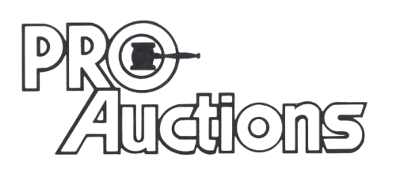
, LLC
Check website for MANY GREAT PICTURES!!
www.proauctionsllc.com
RICK GARNHART, AUCTIONEER
IL Lic: 440000901 WI Lic: 2844-52
German Valley, IL 815-238-3044

