HUGE ALLIS-CHALMERS & OTHERS
TOY AUCTION
SAT. AUG. 27 9:30 A.M.!
BERNARD ALBRIGHT ESTATE – MONROE, WI
AUCTION HELD AT: JANE ADDAMS COMMUNITY CENTER
430 W. WASHINGTON, CEDARVILLE, IL
500+ PCS ALLIS CHALMERS TOYS: PEDAL TRACTORS – AC 9815 WF; AC 45 WD W/ TRAILER; WHITE 6215 WF; OLIVER 70 NF; PEDAL TRACTOR PARTS. A.C. FARM TOYS, 70% NIB: AC 6060 W/ LOADER, D-14 HIGH CROP, 200 SPECIAL; LT70 FWA, 50TH ANNIV. WD-45, MODEL R AIRPLANE, D-15 NF, DEUTZ-AC 6260, DUETZ-AC 6240, HD-3 CRAWLER W/ BACKHOE, D-15 LP, FORRESTON, 6070 ROPS, 6080 FWA, 8010 FWD, 210 W/ DUALS, 2-440 TOY FARMER, IOWA CORN WD45, 180 FFA, 195 IOWA, D-17 PRECISION, D-19 TURBO, FORRESTON, HAT COLLECTION, TIN SIGNS, FRANKLIN MINT 60-A COMBINE NIB, D-17 W/ WAGON, WD-45 W/ LOADER, 3 GLEANER COMBINES, 185 ROPS, 7050 CAB, 7060, MAROON, NASHVILLE 185, BRONZE FARMHAND WD, 190, 212 ROPS, AMANA 190, MODEL K CRAWLER, H-3 CRAWLER, MODEL 4 CHOPPER W/ HEADS. OTHERS: 2 BIG BUD 16V747 NIB, 1/16TH; BIG BUD 370, 1/43RD ; BIG BUD 440 1/43RD; BIG BUD 500 1/43RD; GRAHAM BRADLEY; CASE 800 WF & NF; WISCONSIN FARM TECH IH 340 W/ 2 R. PLANTER; WI FARM TECH MELROE BOBCAT; 500+ 1/64TH TOYS, 50% ORIG. BUBBLE PACKS; MH; COOP #3; IHC THRESHER; CUSTOM NI HAY LOADER; CUSTOM NI 2 R. PULL PICKER; 25+ 1/64TH SEMI TRUCKS NIB; HORSE DRAWN CUSOM HAY RAKE; MM; OIL PULL; PRECISION IHC 560 W/ 2 MH PICKER, NIB; PRECISION JD 4020 W/ 237 PICKER, NIB; PRECISION AC D-17 W/ NI PICKER, NIB; FORD 8N, 901, FORDSON; IHC 460 ORCHARD; OLIVER 770 ORCHARD; 3 TIMEX-6’ REVOLVING DISPLAY CASES; PRECISION OLIVER 77; 2014 CHEESE DAYS OLIVER 1900 WHEATLAND; PLUS 100’S OTHER FARM TOY ITEMS. NOTE: Bernard was a large A.C. Collector w/ many high quality Toys. Also many very good non-A.C. Toys. Definitely a must to attend! Lg. number of toys not listed.
Terms: Cash or check w/ picture ID. Seating, lunch stand & restrooms available.

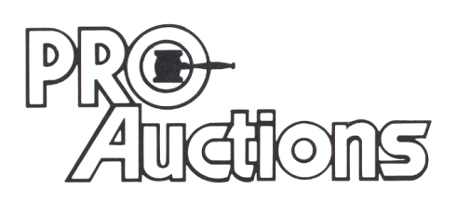
, LLC

Check website for MANY GREAT PICTURES!!
www.proauctionsllc.com
RICK GARNHART, AUCTIONEER
IL Lic: 440000901 WI Lic: 2844-52
German Valley, IL 815-238-3044

