LARGE TOY & MEMORABILIA AUCTION
SAT. JULY 23 9:30 A.M.
JANE ADDAMS COMMUNITY CENTER
430 Washington St., Cedarville, IL 61013
HAROLD BOOK TRUST, BYRON, IL – HUGE A.C. COLLECTION: AC:Model C Custom Pedal Tractor w/ stand & cover, 1/8 WD45 w/ wagon, L&G Set, 1/64 Semi Collection, WD45 Franklin Mint w/ case, Lamp, WC-Louisville, B-125 Engine, 2 Semi Trucks, Mack, Belt Buckle Collection, Lg. amt. AC Adv, Collectibles, etc; IHC: 1/8 M Tractor, M&H Max Armstrong, 1066, IH F-20 Franklin Mint. GENE GREEN COLLECTION, FORRESTON, IL -12 Forreston FFA Oliver Tractors; Bradford Exchange Tractors. STEVE MONIGOLD SIGN COLLECTION & MORE: O’s Gold, Master Mix, Funks G, Victor Seed, Polo, Blaney’s, Pride, Fox Bilt Feeds, Asgrow, Arcadian, Curtiss Bull Stud, Pioneer, Wayne Feeds, Golden Sun Feeds, Renk Seed, Dekalb, Farm Crest, Mandeville Seed, Supersweet Feed, DeLaval, Jacques Seed, Pfister Seed, PAG, Hulting, Oak Brand; BP Clock; 2 Orange & black Phillips 66 plastic Signs 5 ½’x8’; Seed Bags; PLUS MORE QUALITY SIGNS!! CLARENCE LEAVER JR. ESTATE, JUDA, WI: Hand Crafted Wood Farm Toys, highly detailed-1970’s-AC 4WD, Yellow 4WD, Red white Blue 4WD, Green 4WD, Green & Yellow 4WD, Green Log Carrier, IHC SP Combine w/ windrower, IHC 12 B. Plow, Red Soil Tiller, Plus other wood replicas; Steiger #1; JD 3140; Ford 8630; Case 4890; Horse drawn Manure Spreader; Farmall A, SM, STX 375; Bush Hog; Case IHC STX 450; 40”x36”x5’5” Display Case; 48”x36”x13” Display Case; Assort. Cars & Trucks; Amish Built
6-drawer Cabinet Display Case. STRUCTO COLLECTION & OTHER TRUCKS, ROCKFORD, IL: 35+ Structo Trucks incl. pre-war Vehicles, some w/ orig. boxes; Wyandotte; Tonka; Keystone; Arcade; Buddy L, Turner; Kelmet; 2 Johnson Outboard Motors. NAPERVILLE ESTATE: 100+ PCS. EARLY 1960-1980 Farm Sales Literature; 100+ Assort. Trucks, Cars & Tractors. DARREL STYKEL COLLECTION: 200+ Midge & Tootsie Toys; Early Cast Iron; Arcade; Many Promo Cars w/ authentic papers; Other old Cars & Trucks 1/64th (1930-1960). Note: Lg. amt. of high quality toys; very abbreviated list. Advertising Signs are a big bonus, highly sought after. Really good literature also. This is an auction you won’t want to miss.
Seating, lunch stand & restrooms available.
Terms: Cash or check w/ picture ID.

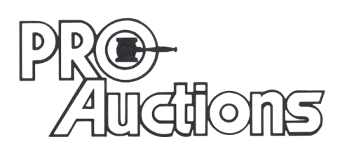
, LLC
Check website for MANY GREAT PICTURES!!
www.proauctionsllc.com
RICK GARNHART, AUCTIONEER
IL Lic: 440000901 WI Lic: 2844-52
German Valley, IL 815-238-3044

