HUGE ANTIQUE ESTATE AUCTION
SAT. JUNE 18, 2022 9:30 A.M.
(RAIN DATE: SUN. JUNE 19)
JAMES AUSMUS ESTATE
N949 Haddinger Rd., Monroe, WI
Location: South of Monroe, WI on 69, 3 miles to Advance Rd, east 2 miles to Haddinger Rd, north ¼ mile to farm.

ANTIQUE TRACTORS & IMPLEMENTS: Restored 1936 J.D. B Tractor w/ new rubber, round spoke rims, set of fenders to fit J.D. A,B, or G; J.D. 60 Gas, wf, hyd, fenders; JD 430, Gas, wf, fenders, 3 pt; Ford Commander 6000, diesel, nf, fenders, 3 pt, 5090 hrs, nice!; Restored Ford 901 select-o-speed, 3 pt,
1948 hrs, parade ready; M.F. 202 Work Bull Tractor w/ MF loader, 3 pt, wts, chains, 2161 hrs; A.C. D-12 Tractor w/ wf, loader, 3 pt, P.A. wheels; Rare Ford Work master (Offset) Tractor w/ 3 pt, wf, front 1 row Cultivator; Ford 2000 Gas Tractor w/ wf, 3 pt; 2-6’ Rear Mt. 3 pt Blades; Ford Loader w/ bucket; A.C. –
6’ Snap Coupler Blade; Flat Rack & Gear; K&K 12’ Cattle Trailer; J.D. 8’ Gang Disk; Ford 3 pt, 3-16 Plow;
20 assort Ford wts; Ford 532 Hay Baler w/ thrower; Ford front bumper; Ford Ferguson 3-16, 3 pt. Plow.
SPECIAL ITEMS: 1999 35TH Anniv. Ford Mustang, black, V-8, auto, 44,000 miles; Rare 1964 Ford T-Bird Convertible w/ V-8, 76,000 miles. MISC: J.D. Advertising Items; J.D. Spitfire Snowmobile; Yamaha Big Wheel; Butcher Kettle; Wagon full assort. Old & New Tools; 2 hyd. Floor Jacks; Air Compressor; Tractor Umbrella; Some Glassware; BEAUTIFUL QUILTS-SOME HAND STITCHED, OLDEST DATED 1911. FARM TOYS: 2 WAGONS FULL OF Farm Toys & Construction: all colors, Structo, J.D., M.M., Case, Wooden Toys. LOCAL ADVERTISING: Wagon full of Adver. Items incl. Clarno, 1st Nat. Bank, 1891 Green Co. Plat Book, 1910 General Store. ANTIQUE FURNITURE: Oak Side by side; Buffet; Carved Oak Hutch; Oak Corner Stand; 1900’s ¾ Bed; Iron Beds; 1902 Cottage Pump Organ; Sohma Piano; Wood Post Bed; Barrel Butter Churn; Crocks & Jugs; Oak Lamp Table w/ glass feet; Drop Leaf Table; Oak Commode; Rare Folding Pine Hutch; Drop front Desk; Maple China Hutch, Plus more! Note: Large auction; many old items from 3 generations of the Ausmus family. Many hard to find items of good quality. Lunch Stand & Port. Toilet on grounds. Terms: Cash or check w/ picture ID.
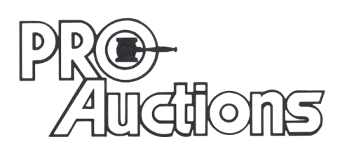
, LLC
Check website for many pictures.
www.Proauctionsllc.com
RICK GARNHART, AUCTIONEER
IL Lic: 440000901 WI Lic: 2844-52
German Valley, IL 815-238-3044

