TERMS OF SALE FOR: GERALD K. MEIER TRUST

AS IS Property is being sold in AS-IS Condition with no warranties expressed or implied.
Buyer is advised to make a thorough inspection.

DEPOSIT Earnest money deposit of 10% day of sale of last bid on each parcel. This
Deposit is NON REFUNDABLE and will be applied to the purchase price at closing.

CLOSING Within 30 days of auction day.

POSSESSION At closing

LEASE Open lease for 2022

CONTINGENCY There are no contingencies including those for inspections or financing.

CONTRACT Successful bidder will be required to enter into a written real estate purchase
agreement. The proposed agreement is available for buyers to review prior to the
start of the auction.

ANNOUNCEMENTS All announcements made on day of sale supersedes all other prior written or
verbal announcements.

RESERVE Sold subject to Trust confirmation.

EVIDENCE OF TITLE Owner will provide merchantable title in the form of a title insurance commitment
and a warranty deed (or equivalent).

REAL ESTATE TAXES SELLER to pay all 2021 Real Estate taxes. Buyer is responsible for all 2022 taxes.

MINERAL RIGHTS All mineral rights owned by SELLER, if any, will be transferred to BUYER.

BUYER’S PREMIUM No buyers’ premium on this sale.

Disclaimer: The information provided is taken from sources believed to be accurate and reliable. However,
no liability is assumed for errors or omissions. There are no warranties, expressed or implied. Buyers are
advised to conduct their own inspection. The Attorneys and Auctioneer conducting the sale are
exclusively representing the seller.
Representing Attorney: Heather McPherson of McPherson Law Offices 815-235-4411

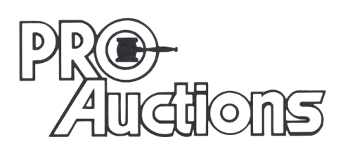
, LLC
RICK GARNHART, AUCTIONEER
IL Lic: 440000901
German Valley, IL 61039
815-238-3044

