HUGE STRUCTO TRUCK, 300+ AUCTION
SAT. MARCH 26 9:30 A.M.!
JAMES AUSMUS ESTATE, CLARNO, WI
JANE ADDAMS COMMUNITY CENTER
430 Washington St., Cedarville, IL 61013

THE 2ND GREAT AUCTION OF THIS ESTATE ”Largest collection of Structo Trucks in the Midwest.” Consists of early Structo, Wyandotte, Nylint, Tonka, Pressed Steel & Keystone.
200+ PCS. STRUCTO (many NIB) incl: Rare early Steel Crawler & Wagon, Cattle Hauler Camper Set, Freight Trucks, Fuel Trucks, Wreckers, Coca-Cola, Sand Loaders, Rocket Launcher Set, Military Set, Car Hauler Sets, Red & Yellow Hook & Ladder, Construction Items, Structo Adver. Items, Assort. Other Semi Trucks, Boat-Motor & Box, Log Hauler, Elec. Serv. Trucks, 1930-40 Dump Trucks, USAF Truck Set, Structo Grills, Fire Pumper, Water Trucks, Several Rider Toys; Plus MANY OTHER STRUCTO PIECES.
OTHERS: Adams Green Sand Loader; Keystone; Pressed Steel; Tonka Feed Trucks; Nylint Semi Trucks; Nylint Horse Trailer; Plus much more.
SPECIAL ITEMS: Lg. Micky Mouse Collection; Roy Rogers items; Howdy Doody items; Pepsi Cola Items; Wood & Steel Pop Cases.
NOTE: Rare high quality Truck & Construction items. Many NIB. Auction held inside
w/ seating & Lunch available. DON’T MISS!!
Terms: Cash or check w/ picture ID. Preview 1 hr. prior to sale.
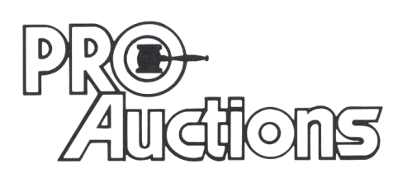
, LLC
Check website for many pictures.
www.Proauctionsllc.com
RICK GARNHART, AUCTIONEER
IL Lic: 440000901
German Valley, IL 815-238-3044

