1000+ FARM TOYS AUCTION
SAT. FEB. 12 9:30 A.M.
(STORM DATE: SUN. FEB. 13)
JANE ADDAMS COMMUNITY CENTER
430 Washington St., Cedarville, IL 61013
James Ausmus Estate, Clarno, WI
LARGE 60 YR. COLLECTION OF HIGH QUALITY FARM TOYS, 80% NIB, MANY RARE & CUSTOMS! Steiger STX 530; Versatile 500;NB Ag Radio Tractors (IHM, JDB, MF1150); Firestone Tractors; Green Co. Cheese Days Tractors; White Tractors:2-155,2-180,6105, 6195,195,160; White 4-110 w/ box; White 9700 Combine w/ seriel #; Dealer wood plaque White Tractor; White 9720 Combine; Silver Agco 7650; Arcade C, A, Plow, Threshing Machine; T.S. Grain Drill & Combine w/ box; Early Ford 861, 981, 6000, 4000, Franklin Mint Baler, P.H. Digger, 3 pt. Plow, Scraper, 961 WF, 961, 9600 Puller, plus others; JD 7520 w/ yellow gang fold Disk, 1/8 Combine, Rare Chain Saw; L, LA, BO, 9630 4x4, STS 9750 Precision, 8430T, 1/8 4430 w/ cab, 1/8 720 Tractor, Besse Truck, Polo, 8030 Precision, 4020 w/ 237 picker, Prestige 55, 60 Combine; Full series Forreston FFA Olivers; Farm Tech Oliver 1600 w/ 74H Picker; Farm Tech Days Oliver 77 w/ Plow; Iowa FFA 660; 1/8 Farmall M w/ Hay Loader; 1/8 IH M w/ Dealer; NH Baler, Chopper, Combine, Haybine, Chopper Box; Tru-Scale Implements; IHC: V-8 Puller, 560 w/ fast hitch, 1066 w/ rops, many blue box Farm Toys, L&G, TD25, 3440 Back Hoe, Green Co. 856, Turbine 341, C-Puller (Gold Digger); Farm Tech IHC 340 w/ Planter; IHC Farm Set; Green Co IHC 856; 1/8 AC WD45 w/ Picker; MFI 150; MF Combines 760, 860; Case 930, 1030; Reuhl MF 44; Reuhl MF 44 w/ Loader; Reuhl MF Combine; Toy Farmer; Fox Chopper 6644; Farm Tech MH22 w/ NI Mower; Farm Tech Case DC Drill 2009; Farm Tech Gehl 820 Chopper; Kinzie: 1050 Grain Cart & 3600 Planter, both NIB. PEDALS: Agco LT85; Ford 8000; Ford 8N; Castelli Yellow Pedal w/ Cart; IHC 560; Oliver Purple 1850. PLUS MUCH MORE!!
Note: Auction held inside w/ seating, Lunch, masks & social distancing. 1st of 3 Auctions for this Estate. Terms: Cash or check w/ picture ID. Preview 1 hr. prior to sale.
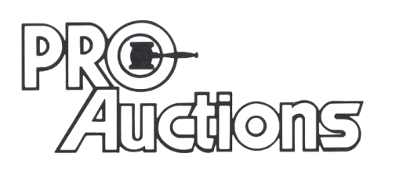
, LLC
Check website for many pictures.
www.Proauctionsllc.com
RICK GARNHART, AUCTIONEER
IL Lic: 440000901
German Valley, IL 815-238-3044

