LARGE FARM TOY AUCTION
SAT. JAN. 22 9:30 A.M.
(STORM DATE: SUN. JAN.23)
JANE ADDAMS COMMUNITY CENTER
430 Washington St., Cedarville, IL 61013
BRAD WURSTER, ELIZABETH, IL
200+ J.D. FARM, TRACTORS & IMPLEMENTS, 90% NIB +MORE – JD: 6030, 7520, 8400,
9400 4x4, 200th Anniv. Set, H.C. 80, Historical Sets, Prestige 45 & 55 Combines, 9860 Combine, 8520, Collectors, Triples, 8400 T, 9400 T, 4230, 620, 5300, Full set Expo Tractors; 6-60th Anniversary Sets, Crawlers: ID, H40, 850, Moline Collectors Set, 40 State Highway, IND 620 & 720, Waterloo Works Tractors, Patio Sets Mod.140, Assort. 1/64; IHC: 7488 2+2 Red Cab, 1486 w/ loader; NI Combine;
Tru Scale: Loader, Tractor, Implements; 1/64 Buildings; 1/16 Wood Barn H.M.; Tonka & Structo Trucks; Plus more misc.
SPECIAL ITEMS: 6’ Glass top Show Case w/ lights; 6’ tall 5 –shelf Circle Show Case; 4’ Glass top Show Case.
150+ M.M. TRACTOR COLLECTION, 90% NIB: Spirit, UTZ, U, R, 1355 D & 1355 LP, 2 Star Crawler w/ blade, 2 Star Crawler w/ bucket; G940 Cheese Days, Gray T.C. Orchard-custom, R. Puller, G850 w/ cab, 1050, 750, Gas Pump-RARE, Resin 1200 Corn Sheller, G450-3 pt. custom, G-1000 open w/ wts,
G-1000 Hot Rod-cream color, Orig. 2 B. Pull Plow w/ hyd, 3 UDLX Tractors, Assort. Show Tractors, G550 FWA, 2-G750 w/ Toy Farmer, BF Avery, Assort. 1/64 & 1/32 MM; Ford: NH Ind. Loader & other Ford Tractors.
JERRY PRASSE 1/64TH COLLECTION: 50 Pcs. All colors Tractors & Implements; 1940 Circus Wagon w/ Horses. Plus other Consignments: Assorted Farm Literature; 100+ 1/16 Tractors & Implements to be unpacked from small estate.
Auction held inside w/ seating, Lunch, masks & social distancing. Terms: Cash or check w/ picture ID. Preview 1 hr. prior to sale.
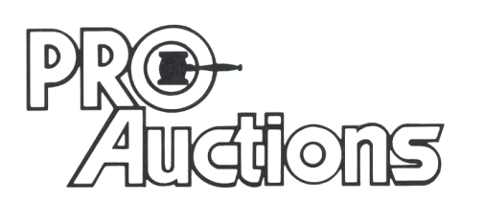
, LLC
Check website for many pictures.
www.Proauctionsllc.com
RICK GARNHART, AUCTIONEER
IL Lic: 440000901
German Valley, IL 815-238-3044

